March 3, 2016
Tim Lange
Head of Investor Relations
Phone +49 201 177-3150
tim.lange@evonik.com
Evonik Industries AG
Rellinghauser Straße 1-11
45128 Essen
Germany
Phone +49 201 177-01
Telefax +49 201 177-3475
www.evonik.com

Supervisory Board
Dr. Werner Müller, Chairman
Executive Board
Dr. Klaus Engel, Chairman
Dr. Ralph Sven Kaufmann
Christian Kullmann
Thomas Wessel
Ute Wolf

Registered office Essen
Registered court
Essen local court
Commercial registry B 19474
VAT ID no. DE 811160003

Evonik invests in Austria to expand membrane business for gas separation

- Strong growth potential, particularly in the nitrogen market
- Investment volume in the mid-double-digit million € range
- Doubling capacities in Austria
- New facility to become operational in late 2017

Evonik Industries is expanding its promising membrane business. To this end, the specialty chemicals company will further expand its Austrian site in Lenzing/Schörfling to double the existing production capacities for the hollow-fiber membrane modules of its SEPURAN® brand. The membrane offers a particularly efficient method for the separation of gases from gas mixtures such as methane, nitrogen, or hydrogen. Evonik is investing an amount in the mid double-digit million € range in the plant and its infrastructure. The production of additional membrane modules is projected to begin in late 2017. Evonik’s investment will also create over 30 new jobs in Schörfling.

“The investment in Austria creates the basis for the further growth of our membrane business in the very attractive market for efficient gas separation. As a technology leader, we want to benefit in an above-average way from the growth in the global gas separation market with our highly selective and productive membranes," said Dr. Ralph Sven Kaufmann, a member of Evonik’s Executive Board and its chief operating officer.

“We aim to expand the biogas membranes business, which has been well-established for five years. At the same time, we see excellent growth opportunities in the market for helium and hydrogen processing as well as for the efficient nitrogen production from air,” noted Dr. Claus Rettig, chairman of the Board of Management of Evonik Resource Efficiency GmbH.

Compared to conventional methods such as cryogenic separation, gas separation via membranes is still a new technology. Because of its higher energy efficiency and lower cost, experts project higher growth for gases from membrane-based separation processes than for conventional gas separation. Nitrogen, with a share of more than 40 percent, has the largest market volume in membrane-based gas separation.

The advantages of Evonik’s membrane technology for gas separation include a more selective separation of gases and high process productivity. Rettig explains: “Our technology let customers take advantage of significantly improved energy efficiency and considerable cost savings. Our new hollow fiber spinning plant will provide our customers with our innovative technology for efficient gas separation with enhanced supply speed and flexibility."

The gas separation modules that Evonik produces in Schörfling are primarily intended for the biogas market and for hydrogen and helium extraction. The new hollow fiber spinning plant will be dedicated to the production of membrane modules for efficient gas separation particularly for nitrogen extraction. The nearby Lenzing plant manufactures polyimide, a high-performance polymer, which is spun and then further processed in Schörfling. The infrastructure in Lenzing will be expanded as well.

The SEPURAN® family produced by Evonik’s Resource Efficiency Segment includes membranes for biogas processing, nitrogen production as well as for helium and hydrogen processing. For over fifty years, the High Performance Polymers Business Line within the Segment has developed and produced high-performance polymers that allow for resource-efficient innovations in a wide range of industries.

SEPURAN® Green membranes for biogas processing were successfully launched in 2011. Since then, the membrane technology has been consistently developed further; the product range has been supplemented with the SEPURAN® Noble membrane for helium and hydrogen processing. A new hollow fiber membrane for efficient nitrogen extraction - SEPURAN® N₂ – was added to the membrane portfolio in early 2016. Protection against fire and explosion, for example in ship and aircraft tanks, is an important application area for nitrogen.

However, the gas also extends the shelf life of foods such as cheese, yoghurt, and fruit and preserves the smell and taste of food.

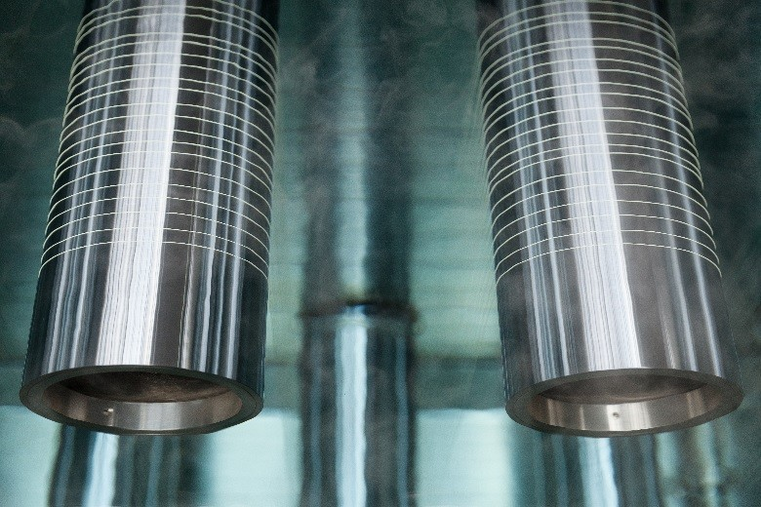

Caption: Polyimide hollow fibers on their way through the spinning bath.

Company information
Evonik, the creative industrial group from Germany, is one of the world leaders
in specialty chemicals. Profitable growth and a sustained increase in the value of the company form the heart of Evonik’s corporate strategy. Its activities focus on the key megatrends health, nutrition, resource efficiency and globalization. Evonik benefits specifically from its innovative prowess and integrated technology platforms.
Evonik is active in over 100 countries around the world. In fiscal 2015 more than 33,500 employees generated sales of around €13.5 billion and an operating profit (adjusted EBITDA) of about €2.47 billion.

About Resource Efficiency
The Resource Efficiency segment is led by Evonik Resource Efficiency GmbH and supplies high performance materials for environmentally friendly as well as energy-efficient systems to the automotive, paints & coatings, adhesives, construction, and many other industries. This segment employed about 8,600 employees, and generated sales of around €4.3 billion in 2015.

Disclaimer
In so far as forecasts or expectations are expressed in this Investor Relations News or where our statements concern the future, these forecasts, expectations or statements may involve known or unknown risks and uncertainties. Actual results or developments may vary, depending on changes in the operating environment. Neither Evonik Industries AG nor its group companies assume an obligation to update the forecasts, expectations or statements contained in this release.

