January 18, 2017

Economic press contact
Silke Linneweber
External Communications
Phone +49 201 177-3389
Fax +49 201 177-3053
silke.linneweber@evonik.com
Specialized press contact
Holger Seier
Head of Communications
Corporate Innovation
Phone +49 201 177-2222
Fax +49 201 177-4322
holger.seier@evonik.com
Evonik Industries AG
Rellinghauser Straße 1-11
45128 Essen
Germany
Phone +49 201 177-01
Fax +49 201 177-3475
www.evonik.com

Supervisory Board
Dr. Werner Müller, Chairman

Executive Board
Dr. Klaus Engel, Chairman
Christian Kullmann, Deputy Chairman
Dr. Ralph Sven Kaufmann
Thomas Wessel
Ute Wolf

Registered Office is Essen
Register Court Essen Local Court
Commercial Registry B 19474
Evonik invests in US-based Nanotech Industrial Solutions (NIS)

- Venture Capital investment includes commercial agreement
- Unique particle technology reduces friction and wear to significantly contribute to engine efficiency
- Evonik’s Oil Additives Business Line expects access to this unique technology to bring high strategic advantage for future market opportunities

Essen/Avenel. Evonik Industries has invested through its venture capital arm in Nanotech Industrial Solutions, Inc. (NIS) headquartered in Avenel (NJ, USA) and now holds a minority share in the company. The parties have agreed not to disclose the volume of the transaction. NIS plans to use the proceeds for further growth of the company. Evonik received a seat on the Board of Directors of NIS. The company, which was founded in 2012, has commercialized a unique particle technology for the lubricants industry and believes to be an emerging leader in high-performance lubricant additives.

NIS produces oil additives for engine oils, oil and water formulations for metalworking fluids, industrial oils and additive formulations for greases. NIS’ patented technology releases nanostructured materials under certain physical conditions. The unique morphology significantly improves friction and wear properties, resulting in a substantial contribution of the technology to resource efficiency of cars, power plants and industrial plants. “By investing in this company, Evonik gains access to inventions in a unique particle technology in lubricants”, said Lutz Stoeber, responsible for Evonik’s Venture Capital activities in North America. An additional strategic fit to Evonik results from the potential of the new technology to bring groundbreaking inventions to the lubricants market.

As part of the investment, NIS and the Oil Additives Business Line completed a commercial agreement. “Evonik believes that the investment will enable the fulfilment of ever more demanding customer requirements,” states Ralf Düssel, head of the Oil Additives Business Line. “What’s more, access to the technology of NIS opens up further development opportunities for our current products as well as new products in our existing and future markets,” he emphasized.

“Today’s announcement marks a key milestone in NIS’ journey to take cutting edge nanotechnology into the lubricant industry. Working together, we [NIS] and Evonik will take transformational products to market in the lubricant additives industry and beyond”, commented Eugene Kverel, President and CEO of NIS.

Evonik’s Oil Additives Business Line develops additive technologies for improving fuel and energy efficiency as well as productivity in engine and gear oils and hydraulic fluids. It focuses on solutions that contribute to the resource-efficient lubricants of tomorrow.

Evonik plans to invest a total of €100 million in promising start-ups with innovative technologies and in leading specialized venture capital funds as part of its venture capital activities.
Regional focuses are Europe, the United States and Asia. Currently, Evonik holds stakes in ten start-ups and four funds. More information is available at http://venturing.evonik.com/.

Caption:
Eugene Kverel, President and CEO of NIS

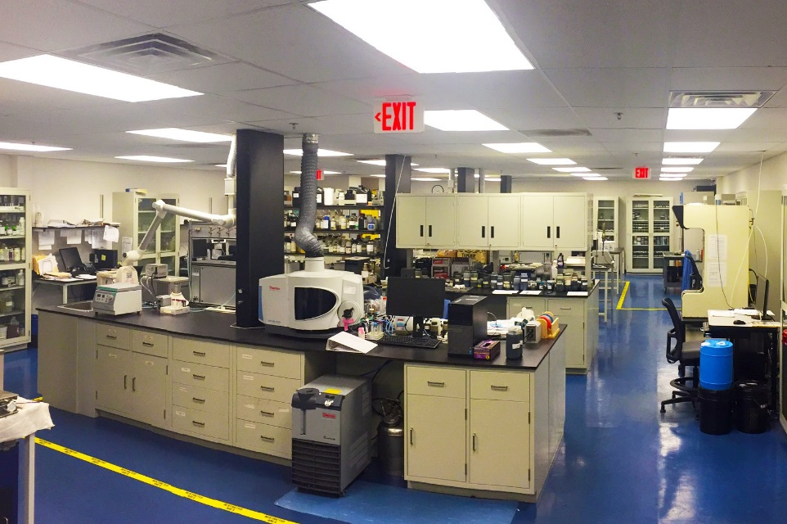

Caption:
Laboratories of NIS

About Evonik
Evonik, the creative industrial group from Germany, is one of the world leaders
in specialty chemicals. Profitable growth and a sustained increase in the value of the company form the heart of Evonik’s corporate strategy. Its activities focus on the key megatrends health, nutrition, resource efficiency and globalization. Evonik benefits specifically from its innovative prowess and integrated technology platforms.

Evonik is active in over 100 countries around the world. In fiscal 2015 more than 33,500 employees generated sales of around €13.5 billion and an operating profit (adjusted EBITDA) of about €2.47 billion.

About NIS
Nanotech Industrial Solutions is the manufacturer of NanoLub®, an innovative nano lubricant and additive based on inorganic particles of fullerene-like tungsten disulfide. These revolutionary particles were first developed in 1992 by Prof. Reshef Tenne who was nominated for a Nobel Prize. The technology is exclusively licensed to Nanotech Industrial Solutions for commercialization Worldwide. NIS has attracted the best minds in the fields of nano technology, chemistry, and various targeted industry applications like lubricating oils, greases, coatings, metal working fluids, polymers and composites. NIS's global corporate office, commercialization R&D lab, manufacturing, blending and packaging facilities are located in Avenel, NJ. More information is available at http://nisusacorp.com/.

Disclaimer
In so far as forecasts or expectations are expressed in this press release or where our statements concern the future, these forecasts, expectations or statements may involve known or unknown risks and uncertainties. Actual results or developments may vary, depending on changes in the operating environment. Neither Evonik Industries AG nor its group companies assume an obligation to update the forecasts, expectations or statements contained in this release.

