January 9, 2015
Business Contact
Dr. Edda Schulze
Corporate Press
Phone +49 201 177-2555
Fax +49 201 177-3030
edda.schulze@evonik.com
Specialized Press Contact
Stefan Cornelissen
Corporate Innovation
Phone +49 201 177-4327
Fax +49 201 177-4322
stefan.cornelissen@evonik.com

Evonik Industries AG
Rellinghauser Straße 1-11
45128 Essen
Germany
Phone +49 201 177-01
Telefax +49 201 177-3475
www.evonik.de

Supervisory Board
Dr. Werner Müller, Chairman
Executive Board
Dr. Klaus Engel, Chairman
Christian Kullmann
Thomas Wessel
Patrik Wohlhauser
Ute Wolf

Registered office Essen
Registered court
Essen local court
Commercial registry B 19474
VAT ID no. DE 811160003

New Chief Innovation Officer at Evonik

Dr. Ulrich Küsthardt has been the new chief innovation officer at Evonik since the beginning of this year. Küsthardt, who succeeds Dr. Peter Nagler, plans to continue strengthening the company’s innovation capacity, continuing his predecessor’s successful work. “Our strategy must be aimed at stimulating Evonik’s growth with attractive fields of innovation. We want to be one of the world’s most innovative companies,” Küsthardt said. Dr. Nagler will remain involved with the topic of innovation and step up efforts to internationalize innovation at Evonik in the future.

Küsthardt, who holds a doctorate in chemistry, began his career at an international consulting firm. Starting in 1997, he held positions at a predecessor of Evonik, initially in controlling as well as in marketing and sales. He later went on to manage various business units, heading up the Coatings & Additives Business Unit of Evonik Industries from 2008.

Innovations are an essential driver for profitable growth at Evonik. They pave the way for new areas of business and strengthen leading market and technology positions. The innovation pipeline of the specialty chemicals company is well-filled with roughly 500 short-, medium-, and long-term projects. To keep up the flow of ideas and innovations in the future, too, the Group has increased its spending on research and development by an average of nine percent per year since 2009. R&D spending in 2013 totaled €394 million.

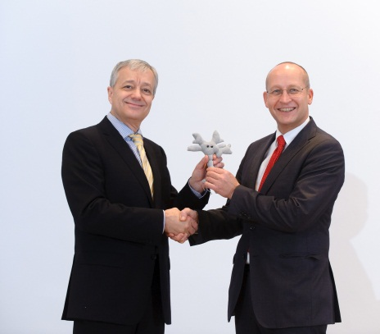

Photo caption: New chief innovation officer at Evonik: Dr. Peter Nagler hands over a cell—symbolizing research, development, and growth—to his successor, Dr. Ulrich Küsthardt
(Photo: Evonik Industries AG)

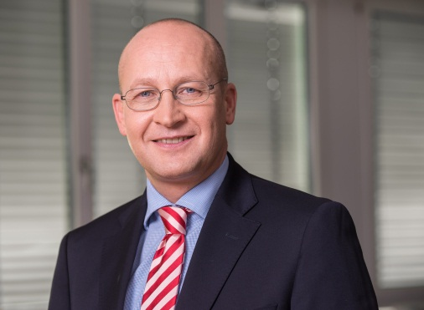
Company information

Photo caption:
Dr. Ulrich Küsthardt, new chief innovation officer at Evonik
(Photo: Evonik Industries AG)

Company information
Evonik, the creative industrial group from Germany, is one of the world leaders
in specialty chemicals. Profitable growth and a sustained increase in the value of the company form the heart of Evonik’s corporate strategy. Its activities focus on the key megatrends health, nutrition, resource efficiency and globalization. Evonik benefits specifically from its innovative prowess and integrated technology platforms.

Evonik is active in over 100 countries around the world. In fiscal 2013 more than 33,500 employees generated sales of around €12.7 billion and an operating profit (adjusted EBITDA) of about €2.0 billion.

Disclaimer
In so far as forecasts or expectations are expressed in this press release or where our statements concern the future, these forecasts, expectations or statements may involve known or unknown risks and uncertainties. Actual results or developments may vary, depending on changes in the operating environment. Neither Evonik Industries AG nor its group companies assume an obligation to update the forecasts, expectations or statements contained in this release.

