November 16, 2017

Contact person specialized press
Doris Hirsch
Global Communication
Molding Compounds
Performance Materials
Phone +49 6151 18 4079
Fax +49 6151 18 84 4079
doris.hirsch@evonik.com
Evonik Performance
Materials GmbH
Rellinghauser Straße 1-11
45128 Essen
Germany
Phone +49 201 177-01
Fax +49 201 177-3475
www.evonik.com

Supervisory Board
Dr. Harald Schwager, Chairman

Managing Directors
Johann-Caspar Gammelin, Chairman
Dr. Michael Pack,
Magdalena Wagner,
Rainer Wobbe

Registered Office Essen
Register Court
City Local Court Essen
Commercial Registry B 25779
Air conditioning unit with touch function: Safer driving thanks to PLEXIMID®

The Preh company has developed a touchscreen using PLEXIMID® that is easier to operate thanks to haptic localization aids. It is currently used in the 4-zone air conditioning unit of the BMW 5 and 7 series.

Caption:
Preh, a specialist in operating systems located in Bad Neustadt an der Saale, has devised a number of concepts that make it easier for drivers to operate touchscreens. © BMW AG

Within just a few years, touchscreens have increasingly taken over from the multitude of knobs and buttons previously used to operate controls. That also applies to the automotive sector. The challenge involved is that drivers must be able to operate the various functions combined in the center console, such as air conditioning and the infotainment system, without taking their eyes off the road. “With knobs and buttons, drivers can feel precisely where their hand is on the control unit,” explains Hans Karl Heil, a development engineer for mechanical design at Preh GmbH. “That is of course not possible with a touchscreen.” The specialist in operating systems located in Bad Neustadt an der Saale has therefore devised a number of concepts that make it easier for drivers to operate touchscreens.

Tactile surface contour
Preh developed an entirely new generation of tactile surface contours for the air conditioning function of the center stack operating system that the BMW Group offers as a special feature to purchasers of the BMW Series 5 and 7. “The surface is slightly indented in places, making it easier to operate,” Heil says. The localization aids are incorporated into the touchscreen membrane made from the thermoplastic PLEXIMID® TT50. This polymethyl methacrylimide (PMMI) with a high heat deflection temperature from Evonik is also used, for example, for light guides in the daytime running light of modern LED headlamps. “Besides its good optical properties, the material also offers very accurate mold surface reproduction, making it ideal for three-dimensional forming,” Heil says. “And we can simply injection-mold the component, which is very important in view of the large number of units required by the automotive industry.”
PLEXIMID® also meets the many other requirements of the automobile industry. “Car interiors are subject to permanent wear and tear, and all the materials used have to withstand those stresses,” explains Dr. Lukas Dössel from Global Product Management PMMI at Evonik. PLEXIMID® shows high chemical resistance, which means it is insensitive to traces of perspiration, creams and food on the hands of people operating the system. Since PMMI, like PMMA, has the highest surface hardness of any thermoplastic, mechanical stress from keys or handbags poses no problem either, especially since Preh has additionally protected the material with a special coating.
High heat deflection temperature
Owing to its high heat deflection temperature, PLEXIMID® also withstands heat buildup in cars parked in full sunlight, which can easily reach temperatures of more than 100 degrees Celsius. “Its low rate of thermal expansion was another crucial point when it came to choosing the material, because we bond the touchscreen membrane to the silicate glass display behind it,” Heil says. “The cover must therefore show very minimal expansion due to temperature fluctuations.”

Uniting design and function
Talking of sunlight, the displays on the operating element can be clearly seen even in sunshine, as Evonik’s PMMI specialist explains: “No other plastic with a high heat deflection temperature shows such low birefringence. This means there are virtually no disturbing color reflections,” Dr. Dössel says. The display can therefore be read even by people wearing polarized sunglasses. So there are many reasons why PLEXIMID® and high-tech operating systems from Preh offer a successful combination for safe driving.

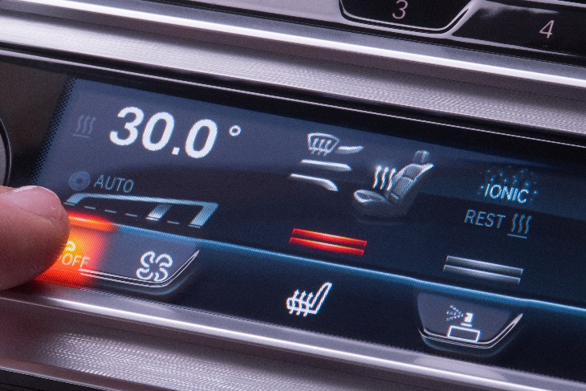

Caption:
The easy-to-operate touchscreen made from PLEXIMID®, currently used in the 4-zone air conditioning unit of the BMW Series 5 and 7.

Evonik is a worldwide manufacturer of PMMA products sold under the PLEXIGLAS® and PLEXIMID® trademarks on the European, Asian, African and Australian continents and under the ACRYLITE® and ACRYMID® trademarks in the Americas.

Company information
Evonik is one of the world leaders in specialty chemicals. The focus on more specialty businesses, customer-orientated innovative prowess and a trustful and performance-oriented corporate culture form the heart of Evonik’s corporate strategy. They are the lever for profitable growth and a sustained increase in the value of the company. Evonik benefits specifically from its customer proximity and leading market positions. Evonik is active in over 100 countries around the world with more than 36,000 employees. In fiscal 2016, the enterprise generated sales of around €12.7 billion and an operating profit (adjusted EBITDA) of about €2.165 billion.

About Performance Materials
The Performance Materials Segment is managed by Evonik Performance Materials GmbH. The segment focuses its global activities on developing and manufacturing polymer materials and intermediates, especially for use in agriculture and in the rubber and plastics industry. In 2016, the segment’s roughly 4,400 employees generated sales about €3.2 billion.

Disclaimer
In so far as forecasts or expectations are expressed in this press release or where our statements concern the future, these forecasts, expectations or statements may involve known or unknown risks and uncertainties. Actual results or developments may vary, depending on changes in the operating environment. Neither Evonik Industries AG nor its group companies assume an obligation to update the forecasts, expectations or statements contained in this release.

