May 30, 2016
Contact person specialized press
Jochen Henkels
Coating & Adhesive Resins
Phone +49 6181 59-6104
jochen.henkels@evonik.com
Evonik Resource Efficiency GmbH
Rellinghauser Straße 1-11
45128 Essen
Phone +49 201 177-01
Fax +49 201 177-3475
www.evonik.com

Supervisory Board
Dr. Ralph Sven Kaufmann, Chairman

Executive Board
Dr. Claus Rettig, Chairman
Dr. Johannes Ohmer,
Simone Hildmann,
Alexandra Schwarz

Registered Office: Essen
Register Court: Essen Local Court
Commercial Registry B 25783
VAT ID no. DE 815528487

Evonik promotes child road safety education

An observant employee with the right idea, a people-oriented mayor with an appreciation of child-oriented road safety education, and a neighboring company with a sense of regional responsibility were the ingredients for a small yet valuable project implemented by Evonik in Hanau.

Ronneburg is an attractive, livable, and likeable small town in the district of Main-Kinzig. Around 3,500 people live here, some 16 kilometers from the city gates of Hanau. One of its residents is Michael Pieroth, a technical service manager from Evonik’s Resource Efficiency Segment with responsibility for DEGAROUTE®, a reaction resin for durable cold plastic road markings. Some time ago, a coincidence led him to the road safety circuit in his own town, where his expert eye immediately noticed that the markings were in urgent need of a facelift. In the 40 or so years in which the circuit had been in existence, wind and weather had taken a heavy toll on the place where Michael Pieroth himself had started learning the rules of the road on his bicycle many years before and made the markings barely visible.

And so, an idea began to form in Pieroth’s mind, which was directly implemented following a short consultation with his boss, Dr. Alexander Klein. For some time, the technical service managers had been on the lookout for a place where new employees could be trained on the actual object. This led to the road safety circuit in Ronneburg being summarily turned into a testing ground. Here, the new technicians were able to apply road markings, putting the theoretical knowledge they had previously acquired into practice.

Andreas Hofmann, Mayor of Ronneburg, spoke enthusiastically of Evonik’s commitment: “Situations on the road can quickly become dangerous for children in particular. This is why our town places high value on road safety education—starting in kindergarten. Thanks to Evonik’s magnificent work, our children can now learn the right way to cycle on the road again by playing on a really well-

prepared road traffic circuit. Evonik has shown that it is a strong local partner—and not just as an employer.” Here’s to continuing the good neighborhood relations!

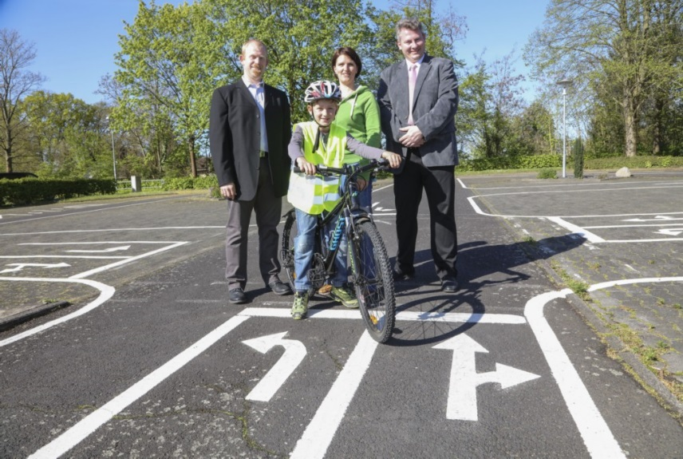

Caption:
Evonik applied DEGAROUTE® road markings on the road safety circuit in Ronneburg (Hessen, Germany).

Company information
Evonik, the creative industrial group from Germany, is one of the world leaders in specialty chemicals, operating in the Nutrition & Care, Resource Efficiency and Performance Materials segments. The company benefits from its innovative prowess and integrated technology platforms. In 2015 more than 33,500 employees generated sales of around €13.5 billion and an operating profit (adjusted EBITDA) of about €2.47 billion.

About Resource Efficiency
The Resource Efficiency segment is led by Evonik Resource Efficiency GmbH and supplies high performance materials for environmentally friendly as well as energy-efficient systems to the automotive, paints & coatings, adhesives, construction, and many other industries. This segment employed about 8,600 employees, and generated sales of around €4.3 billion in 2015.

Disclaimer
In so far as forecasts or expectations are expressed in this press release or where our statements concern the future, these forecasts, expectations or statements may involve known or unknown risks and uncertainties. Actual results or developments may vary, depending on changes in the operating environment. Neither Evonik Industries AG nor its group companies assume an obligation to update the forecasts, expectations or statements contained in this release.

