Evonik and SCREEN FT enter strategic partnership to promote iXsenic® technology

German chemical company Evonik Industries AG and Japanese FPD production equipment manufacturer SCREEN Finetech Solutions Co., Ltd. have signed a contract for a strategic partnership in order to offer best performance of perfectly matched iXsenic® semiconductor material, equipment and process.
iXsenic® is a solution-processable inorganic metal oxide semiconductor which is applied under ambient conditions. No vacuum environment is needed which results in process simplifications, high yield and cost advantages. iXsenic® is best applied via slot-die coating.

The Japanese company SCREEN Finetech Solutions Co., Ltd. provides a wide range of equipment and services for the FPD industry including high-quality coating machines like slot-die/ slit coater (Linearcoater※). In the FPD industry SCREEN FT is the global technology and market leader for such equipment.
Evonik and SCREEN FT have been running application tests with iXsenic® on Linearcoater for years. Now they have signed a contract for a strategic partnership to jointly promote the iXsenic® technology. “With SCREEN FT we have found the perfect partner”, says Prof. Ralf Anselmann, Vice President at Evonik. “The advantages are obvious: Evonik offers the semiconductor iXsenic®, SCREEN FT provides the production equipment. Thus, material, equipment and process can be perfectly matched to the customer’s needs. With this setup we will offer optimal service and performance to our customers.”

October 19, 2015

Contact person press
Evonik Resource Efficiency
Thomas Lange
Tel +49 201 173-3050
thomas.lange2@evonik.com

Business Promotion Department , SCREEN Finetech Solutions Co., Ltd.
Tel +81-75-417-2570
fpdinfo@screen.co.jp

Evonik Resource Efficiency GmbH
Rellinghauser Strasse 1-11
45128 Essen
Germany
Phone +49 201 177-01
Fax +49 201 177-3475
www.evonik.com/iXsenic
www.ixsenic.com

Supervisory Board
Dr. Ralph Sven Kaufmann, Chairman
Managing Directors
Dr. Claus Rettig, Chairman
Dr. Johannes Ohmer, Simone Hildmann, Alexandra Schwarz

Registered Office: Essen
Register Court: Essen Local Court
Commercial Registry B 25783
VAT ID no. DE 815528487

Material layers like photo resists are already coated today in the Electronics industry but semiconductive layers are normally applied via vapor deposition (CVD or PVD). With the solution-processable iXsenic® material it is now possible to coat the semiconductor. “With our partnership we expect faster and easier integration of the iXsenic® technology at the customer’s site including higher reliability for mass production” comments Mitsumasa Kodama, Deputy General Manager at SCREEN Holdings. “And not to forget: with perfectly matched material and equipment mobilities above 10 cm²/Vs are not just a champion’s value but reality.”

The strategic partnership of Evonik and SCREEN FT is the consequent next step to strengthen the commercialization of the iXsenic® technology.

For further information please visit our websites
- www.iXsenic.com (English)
- www.screen.co.jp/fpd(Japanese)
- www.iXsenic.com.cn (Mandarin).

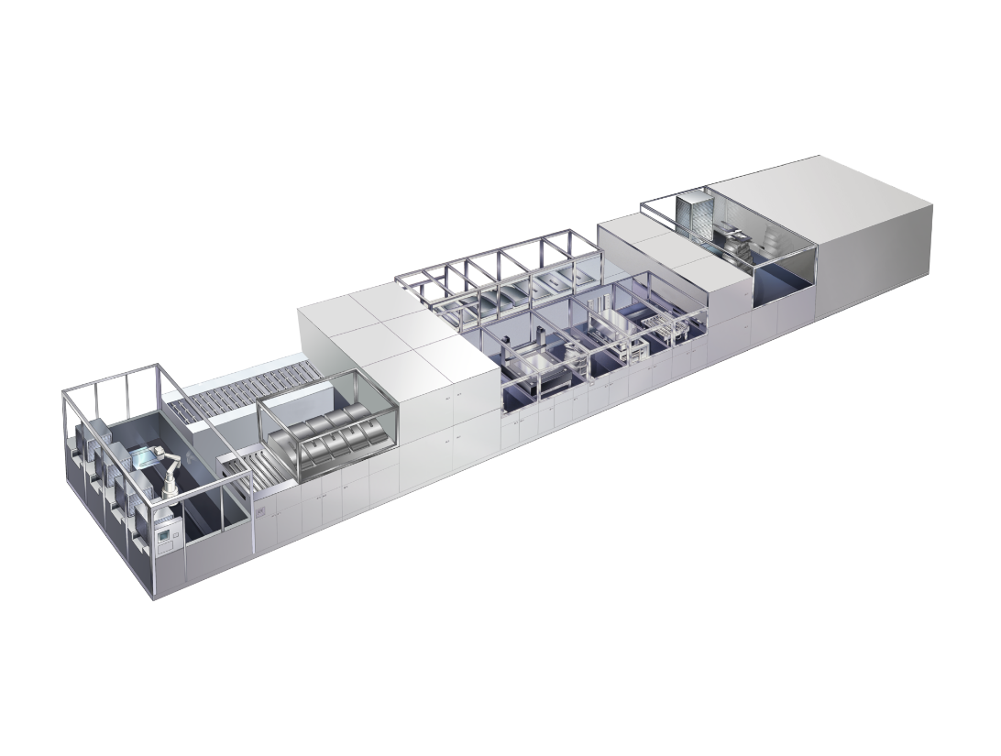

Capture: Specially designed coater system for high resolution TFTs

About Resource Efficiency

The Resource Efficiency segment is led by Evonik Resource Efficiency GmbH and brings together Evonik’s activities in specialty chemicals for industrial applications. The Resource Efficiency segment supplies high performance materials for environmentally friendly as well as energy-efficient systems to the automotive, paints & coatings, adhesives, construction, and many other industries. This segment employed about 7,800 employees, and generated sales of around €4 billion in 2014.

About Evonik

Evonik, the creative industrial group from Germany, is one of the world leaders in specialty chemicals, operating in the Nutrition & Care, Resource Efficiency and Performance Materials segments. The company benefits from its innovative prowess and integrated technology platforms. In 2014 more than 33,000 employees generated sales of around €12.9 billion and an operating profit (adjusted EBITDA) of about €1.9 billion.

About SCREEN Finetech Solutions

SCREEN Finetech Solutions Co., Ltd. (SCREEN FT) is a key business operating company of SCREEN Holdings Co., Ltd. As the world’s leading company dealing in FPD production equipment, SCREEN FT has expanded its product lineups such as FPD coater/developers and a variety of coating equipment for the energy industry. These advances are based on its core technologies in surface processing, which have been cultivated over many years.
In 2014, SCREEN FT inherited Dainippon Screen’s FPD equipment and other related business.
※ Linearcoater is a Japanese trademark of SCREEN Holdings Co., Ltd.

About SCREEN Holdings

SCREEN Holdings Co., Ltd. (SCREEN HD) was established in 1943 under the name of Dainippon Screen Mfg. Co., Ltd. SCREEN HD manages a total of 46 group companies worldwide. These operations manufacture and distribute many of the world’s leading products in areas including semiconductor cleaning equipment, computer to plate (CTP) recorders for printing and flat panel display (FPD) coater/developers.

Disclaimer
In so far as forecasts or expectations are expressed in this press release or where our statements concern the future, these forecasts, expectations or statements may involve known or unknown risks and uncertainties. Actual results or developments may vary, depending on changes in the operating environment. Neither Evonik Industries AG nor its group companies assume an obligation to update the forecasts, expectations or statements contained in this release.

