July 16, 2014
Contact person economic press
Silke Linneweber
Corporate Press
Phone +49 201 177-3389
Fax +49 201 177-3030
silke.linneweber@evonik.com
Contact person specialized press
Dr. Karin Aßmann
Innovation Networks & Communication
Phone +49 6181 59-12230
Fax +49 6181 59-712230
karin.assmann@evonik.com

Evonik Industries AG
Rellinghauser Straße 1-11
45128 Essen
Germany
Phone +49 201 177-01
Telefax +49 201 177-3475
www.evonik.de

Supervisory Board
Dr. Werner Müller, Chairman

Executive Board
Dr. Klaus Engel, Chairman
Christian Kullmann
Thomas Wessel
Patrik Wohlhauser
Ute Wolf
Registered office Essen
Registered court
Essen local court
Commercial registry B 19474
VAT ID no. DE 811160003

Evonik invests in Biosynthetic Technologies,
a specialist in biobased lubricants

- Biosynthetic Technologies markets innovative, biodegradable, high-performance lubricants
- Vegetable oils used as raw material
- Automotive market to drive future growth

Evonik has closed on an equity investment in Biosynthetic Technologies, LLC (BT), a specialist in biobased lubricants headquartered in Irvine (California, USA). BT has developed and manufactures a new class of bio-based synthetic oils called estolides that are used primarily in the passenger car motor oil and industrial lubricant sectors. Field trials have shown that the technical characteristics of the biobased synthetic oils made by BT are exceptionally good, and include the ability to combat soot buildup in engines, which helps keep fuel consumption low. In addition to Evonik, BP Ventures also participated as a second strategic investor in this current funding round that focuses on growth. BP Ventures as well as Monsanto Company have already invested in previous financing rounds.

“Biosynthetic Technologies leads the way to high-quality sustainable lubricants,” says Dr. Bernhard Mohr, head of Evonik Venture Capital. “In view of the large automotive market and the strong trend towards fuel-economy and sustainability, this is a growing market with a strong fit to Evonik´s oil additives business."

“We are excited to have Evonik join us as a strategic investor,” says Allen Barbieri, CEO of Biosynthetic Technologies. “In addition to its capital investment, Evonik brings world class manufacturing, R&D and sales & marketing expertise that will expedite our commercialization process.”

Evonik is a leader in the development of technologies for the production of lubricant additives. Its high-performance additives
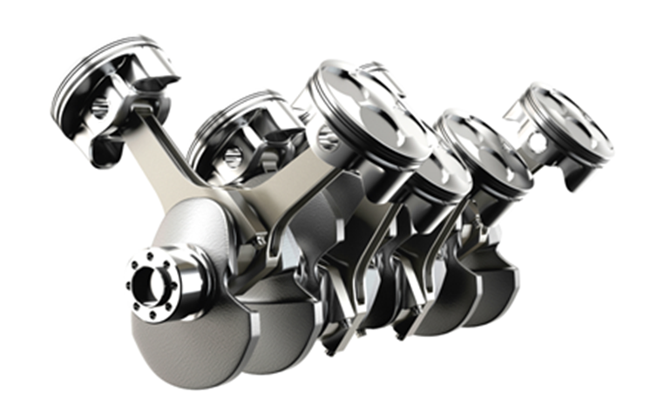
increase both productivity and fuel efficiency. Regional technology centers, modern global manufacturing centers, and a secure and reliable supply chain worldwide enable Evonik’s continuous development of customized solutions for customers anywhere in the world.

Biosynthetic Technologies’ new class of bio-based synthetic oils are made from organic fatty acids found in plant oils and have numerous uses in the lubricant, chemical, and cosmetics industries. They are biodegradable, nontoxic and they do not bio-accumulate in marine life. BT holds a broad patent portfolio to protect these novel biosynthetic oils that are marketed under the trade name LubriGreen® Biosynthetic Oils.

BT’s lubricants are now being tested and certified by many of the world’s largest lubricant manufacturers who want to use these as components in their existing or new motor oil and industrial lubricant product lines.

Within its venture capital activities Evonik plans to invest a total of €100 million in highly promising start-ups with break-through technologies and leading specialist venture capital funds. These investments will focus on Europe, the U.S. and Asia. Partnering with innovative start-up companies supplements Evonik’s approach of open innovation and creates excellent opportunities for accelerating the development of new businesses and opening up future growth fields.

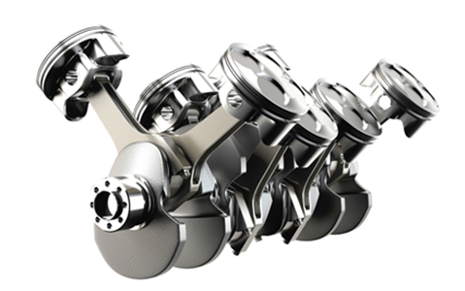
Caption:
The benefits of biobased oils from BT include helping keep engines clean and fuel consumption low.
(Photo: Biosynthetic Technologies)

About Evonik
Evonik, the creative industrial group from Germany, is one of the world leaders in specialty chemicals. Profitable growth and a sustained increase in the value of the company form the heart of Evonik’s corporate strategy. Its activities focus on the key megatrends health, nutrition, resource efficiency and globalization. Evonik benefits specifically from its innovative prowess and integrated technology platforms.

Evonik is active in over 100 countries around the world. In fiscal 2013 more than 33,500 employees generated sales of around €12.7 billion and an operating profit (adjusted EBITDA) of about €2.0 billion.

About Biosynthetic Technologies
Biosynthetic Technologies was formed in 2004 and received an exclusive license to a patent portfolio issued to the U.S. Department of Agriculture (USDA) which covers the production of estolides from plant oils. Since that time the company has built a demonstration manufacturing plant, gained significant market interest and extended their patent portfolio. The company is headquartered in Irvine, CA, the demonstration plant is at an Albemarle site in Baton Rouge, Louisiana. For more information, visit http://biosynthetic.com.

Disclaimer
In so far as forecasts or expectations are expressed in this press release or where our statements concern the future, these forecasts, expectations or statements may involve known or unknown risks and uncertainties. Actual results or developments may vary, depending on changes in the operating environment. Neither Evonik Industries AG nor its group companies assume an obligation to update the forecasts, expectations or statements contained in this release.

