June 29, 2018

Specialized Press Contact
Susanne Diehl
Communication Silica
Phone +49 6181 59-13347
susanne.sd.diehl@evonik.com

Evonik Resource Efficiency GmbH
Rellinghauser Straße 1-11
45128 Essen
Phone +49 201 177-01
Fax +49 201 177-3475
www.evonik.com

Supervisory Board
Dr. Harald Schwager, Chairman

Managing Directors
Dr. Claus Rettig, Chairman
Dr. Johannes Ohmer
Simone Hildmann
Alexandra Schwarz

Registered Office: Essen
Register Court: Essen Local Court
Commercial Registry B 25783
VAT ID no. DE 815528487

Evonik increases its precipitated silica capacity in Turkey

- Investment strengthens Smart Materials growth engine and further expands leading market position
- As strong partner of tire manufacturers, Evonik serves the high demand for silica
- An additional capacity of 40,000 metric tons available from 2020

Essen (Germany)/Adapazari (Turkey). Evonik Industries is continuing to expand its silica production capacity in response to high demand within the tire industry. Precipitated silica are an essential ingredient in tires with reduced rolling resistance and, as part of Smart Materials, belong to one of the four strategic growth engines of Evonik with an above-average market growth and margin potential.

The company will increase its annual production capacity for precipitated silica at the existing site in Adapazari (Turkey) by 40,000 metric tons, investing a sum in the lower double-digit million euro range. Evonik and the EGE KIMYA company operate a joint venture in Turkey. Startup of the new production complex is scheduled for 2020. In addition to producing ULTRASIL® rubber silica, it will also serve the growing needs for precipitated silica.

“As a powerful partner for the tire industry and one of the world’s leading producers of silica products such as ULTRASIL®, with this capacity expansion, we are reacting to the massive demand in the industry, strengthening our business partnership with the tire manufacturers,” says Dr. Johannes Ohmer, a member of the Evonik Resource Efficiency GmbH Board of Management.

“This is a consistent response to the challenge of reliably providing innovative products and custom solutions to our regional customers,” points out Andreas Fischer, head of the Silica Business Line. Evonik is implementing this expansion in Adapazari to support the high level of demand for the highly dispersible (HD) silica used in producing Green Tires, particularly from customers in southeastern Europe and the Middle East. Thanks to a significantly reduced rolling resistance, Green Tires save a considerable amount of fuel compared to traditional vehicle tires.

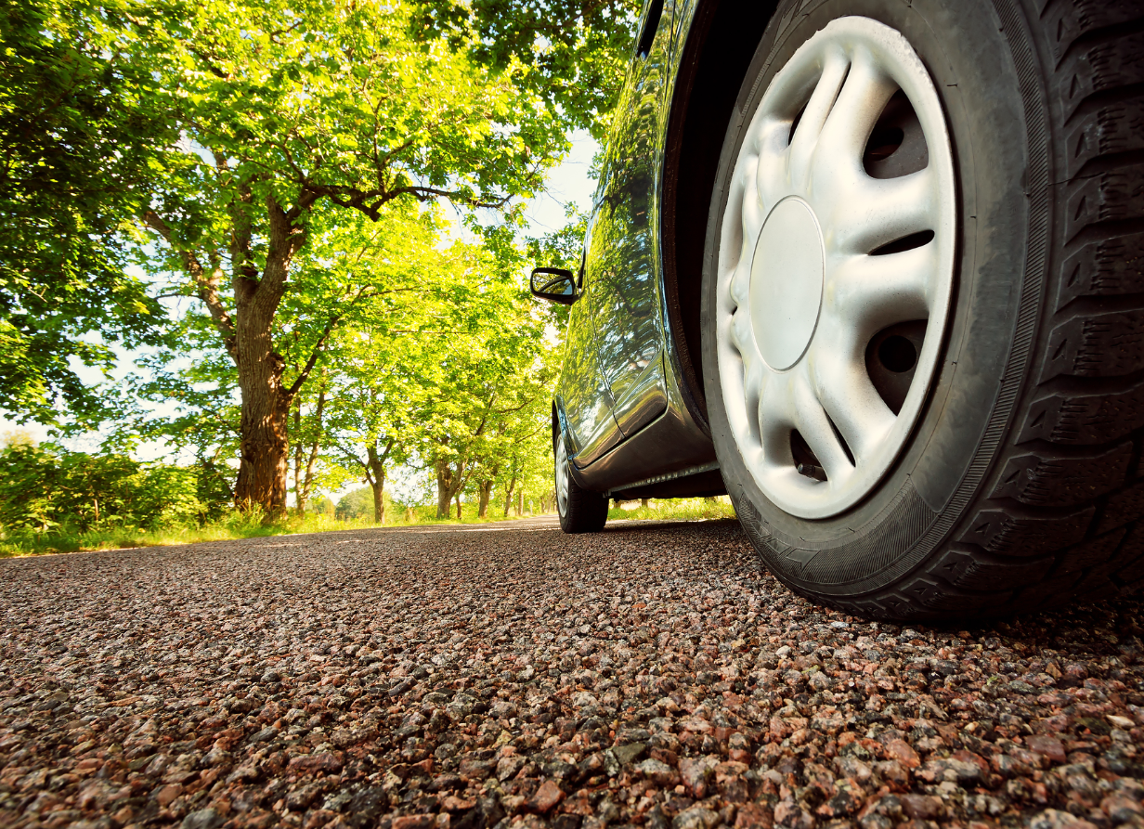

Caption:
The Green Tires that are made with the help of Silica/Silane technology from Evonik save fuel, thanks to their low rolling resistance.

About Evonik
Evonik is one of the world leaders in specialty chemicals. The focus on more specialty businesses, customer-orientated innovative prowess and a trustful and performance-oriented corporate culture form the heart of Evonik’s corporate strategy. They are the lever for profitable growth and a sustained increase in the value of the company. Evonik benefits specifically from its customer proximity and leading market positions. Evonik is active in over 100 countries around the world with more than 36,000 employees. In fiscal 2017, the enterprise generated sales of €14.4 billion and an operating profit (adjusted EBITDA) of €2.36 billion.

About Resource Efficiency
The Resource Efficiency segment is led by Evonik Resource Efficiency GmbH and produces high performance materials and specialty additives for environmentally friendly as well as energy-efficient systems to the automotive, paints & coatings, adhesives, construction, and many other industries. This segment employed about 10,000 employees, and generated sales of around €5.4 billion in 2017.

Disclaimer
In so far as forecasts or expectations are expressed in this press release or where our statements concern the future, these forecasts, expectations or statements may involve known or unknown risks and uncertainties. Actual results or developments may vary, depending on changes in the operating environment. Neither Evonik Industries AG nor its group companies assume an obligation to update the forecasts, expectations or statements contained in this release.

