May 8, 2015
Contact Person Economic Press
Ruben Thiel
Corporate Press
Phone +49 201 177-4299
Fax +49 201 177-3030
ruben.thiel@evonik.com
Contact Person Specialized Press
Sabine Bertich
Technology & Infrastructure
Communication & Integration
Phone +49 201 177-2782
sabine.bertich@evonik.com

Evonik Industries AG
Rellinghauser Straße 1-11
45128 Essen
Germany
Phone +49 201 177-01
Fax +49 201 177-3475
www.evonik.de

Supervisory Board
Dr. Werner Müller, Chairman
Executive Board
Dr. Klaus Engel, Chairman
Christian Kullmann
Thomas Wessel
Patrik Wohlhauser
Ute Wolf

Registered office Essen
Registered court
Essen local court
Commercial registry B 19474
VAT ID no. DE 811160003

Maintenance specialists name Evonik as Europe’s best employer

- The specialty chemicals company takes top place in the European HR Award Maintenance
- Decision based on high level of employee satisfaction

Antwerp. Evonik Industries makes a good impression on employees. For this, the specialty chemicals group received the European HR Award Maintenance, which reflects the satisfaction of maintenance specialists with employers. The European Federation of National Maintenance Societies (EFNMS) presented the award in Antwerp on the occasion of Euromaintenance 2015, Europe’s largest maintenance trade show.

The winner had been selected on the results of a scientifically designed survey, with Evonik prevailing against strong competition from the whole of Europe. Thomas Wessel, member of the Executive Board and Evonik’s Chief Human Resources Officer, says: “Evonik is regarded as a particularly attractive employer for qualified junior staff in technical professions. That’s cause for celebration—and it spurs us to do even better in the future.”

Survey respondents had to assess such aspects as qualification, continuing education, and health and safety management as well as their area of operations and actual working conditions. In their evaluation of Evonik, the young employees from the company’s Technical Service in Germany and Belgium could also indicate whether they would recommend their employer to others.
“We are delighted to receive this award, particularly as it's based on evaluation by our employees,” says Stefan Behrens, who is responsible for HR at Evonik Technology & Infrastructure.
“We will continue to strive to win qualified young employees for Evonik, support the professional development of our technical experts and managerial staff, and offer them a good work environment.”

As one of the world leaders in specialty chemicals Evonik Industries is active in more than 100 countries around the world. Accordingly, Evonik also positions itself internationally as an employer with the promise of “Exploring opportunities. Growing together.” Wessel explains what he understands by this: “Evonik offers a wide range of global opportunities for development and career advancement, with the focus on international collaboration and team spirit. Because it’s very clear to us that our employees are the key to the company's success.”

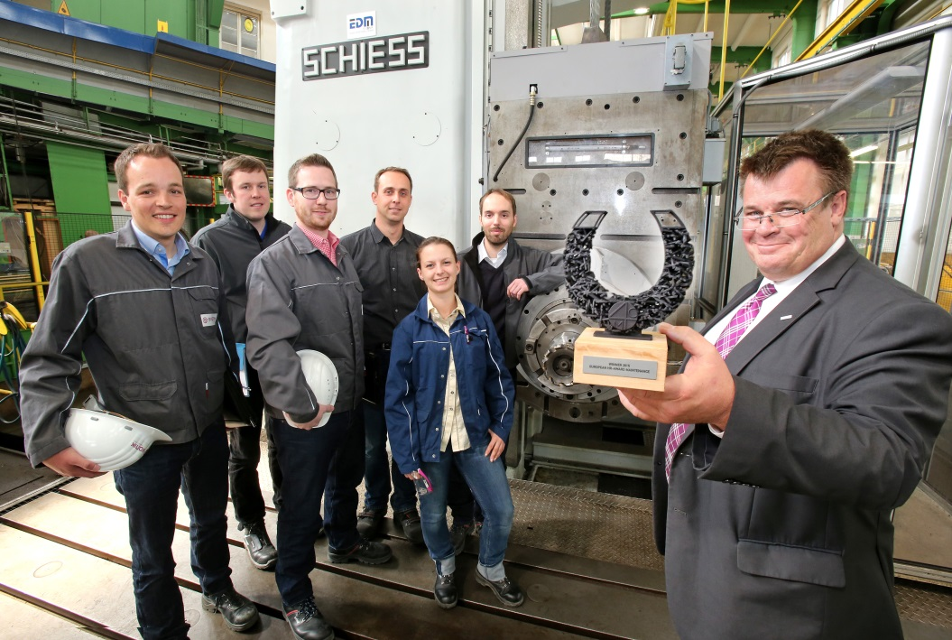
Caption:
"A good employer for junior technical staff: Young professionals at Evonik’s Technical Service celebrate the company’s award together with Dr. Andreas Weber, Head of Business Development (right), at the Marl site."

Company information
Evonik, the creative industrial group from Germany, is one of the world leaders
in specialty chemicals. Profitable growth and a sustained increase in the value of the company form the heart of Evonik’s corporate strategy. Its activities focus on the key megatrends health, nutrition, resource efficiency and globalization. Evonik benefits specifically from its innovative prowess and integrated technology platforms.

Evonik is active in over 100 countries around the world. In fiscal 2014 more than 33,000 employees generated sales of around €12.9 billion and an operating profit (adjusted EBITDA) of about €1.9 billion.

Disclaimer
In so far as forecasts or expectations are expressed in this press release or where our statements concern the future, these forecasts, expectations or statements may involve known or unknown risks and uncertainties. Actual results or developments may vary, depending on changes in the operating environment. Neither Evonik Industries AG nor its group companies assume an obligation to update the forecasts, expectations or statements contained in this release.

