September 30, 2013
Contact person economic press
Silke Linneweber
Corporate Press
Phone +49 201 177-3389
Fax +49 201 177-3030
silke.linneweber@evonik.com
Evonik Industries AG
Rellinghauser Straße 1-11
45128 Essen
Germany
Phone +49 201 177-01
Telefax +49 201 177-3475
www.evonik.de

Supervisory Board
Dr. Werner Müller, Chairman
Executive Board
Dr. Klaus Engel, Chairman
Dr. Wolfgang Colberg,
Dr. Thomas Haeberle,
Thomas Wessel, Patrik Wohlhauser, Dr. Dahai Yu

Registered office Essen
Registered court
Essen local court
Commercial registry B 19474
VAT ID no. DE 811160003

Evonik supporting Syrian refugee children in Jordan

- The company is donating €35,000 for a new preschool in the Zaatari refugee camp in Jordan
- Executive Board Member Dr. Thomas Haeberle: “The aim of our donation is to help provide a completely normal daily routine for the children in Zaatari.”
- Renewed collaboration with children’s rights organization Save the Children

Evonik Industries is donating €35,000 for Syrian refugee children. Save the Children, a children’s rights organization, is the recipient of the donation. It has earmarked the funds toward a new preschool at the Zaatari refugee camp in Jordan. According to Executive Board Member Dr. Thomas Haeberle, who is responsible for the Resource Efficiency Segment and the Middle East, “The aim of our donation is to help provide a completely normal daily routine for the children in Zaatari.”

Save the Children maintains two preschools at Zaatari, where the organization provides child care for children under five years of age. A third facility will now be added. "For children who have experienced so much distress it is essential that they have a place to stay where they can play and learn undisturbed. Preschools are ideal for this purpose, restoring a margin of security for the girls and boys," says Kathrin Wieland, managing director of Save the Children in Germany. In addition to child care, Save the Children also provides support for mothers in Zaatari. Some 320 children and 200 parents will benefit directly from the three preschools at the camp.

As one of the world’s leading producers of specialty chemicals, Evonik also has operations in the Middle East. The company has worked with Save the Children on multiple occasions, such as the aftermath of the earthquake and tsunami disaster in Japan in the spring of 2011.

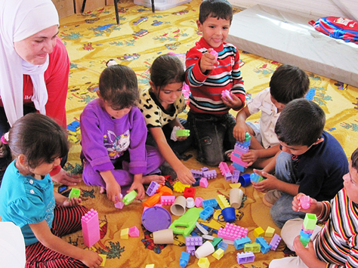

Picture: Refugee children in a preschool in the Zaatari refugee camp in Jordan.

Company information
Evonik, the creative industrial group from Germany, is one of the world leaders
in specialty chemicals. Profitable growth and a sustained increase in the value of the company form the heart of Evonik’s corporate strategy. Its activities focus on the key megatrends health, nutrition, resource efficiency and globalization. Evonik benefits specifically from its innovative prowess and integrated technology platforms.

Evonik is active in over 100 countries around the world. In fiscal 2012 more than 33,000 employees generated sales of around €13.4 billion and an operating profit (adjusted EBITDA) of about €2.4 billion (excluding Real Estate in both cases).

Disclaimer
In so far as forecasts or expectations are expressed in this press release or where our statements concern the future, these forecasts, expectations or statements may involve known or unknown risks and uncertainties. Actual results or developments may vary, depending on changes in the operating environment. Neither Evonik Industries AG nor its group companies assume an obligation to update the forecasts, expectations or statements contained in this release.

