September 23, 2014
Contact person economic press
Silke Linneweber
Corporate Press
Phone +49 201 177-3389
Fax +49 201 177-3030
Silke.linneweber@evonik.com
Contact person specialized press
Dr. Karin Aßmann
Corporate Innovation Strategy & Management
Phone +49 6181 591-2230
Fax +49 6181 59-712230
karin.assmann@evonik.com

Evonik Industries AG
Rellinghauser Straße 1-11
45128 Essen
Germany
Phone +49 201 177-01
Telefax +49 201 177-3475
www.evonik.de

Supervisory Board
Dr. Werner Müller, Chairman
Executive Board
Dr. Klaus Engel, Chairman
Christian Kullmann
Thomas Wessel
Patrik Wohlhauser
Ute Wolf

Registered office Essen
Registered court
Essen local court
Commercial registry B 19474
VAT ID no. DE 811160003

New ROHACELL® structural foam conquers the skies

- New lightweight material from Evonik can withstand even extreme changes in temperature and high mechanical stress
- Cost- and energy-saving alternative to honeycomb composites for safety-relevant aircraft applications
- Airbus is testing components made of ROHACELL® HERO for potential series production

With the structural foam ROHACELL® HERO Evonik wants to open up new markets for Evonik in the aircraft industry. The lightweight material developed by Evonik can withstand even extreme changes in temperature and high mechanical stress, thereby fulfilling the requirements for external aircraft components where safety is a significant factor. Until now, only honeycomb composites, as they are known, were able to meet these demands. As Joachim Leluschko, head of Evonik’s High Performance Polymers Business Line, explains, “Weight is a very important issue in aviation and the industry is therefore searching for lightweight solutions. ROHACELL® HERO means there is now a cost-saving and energy-saving alternative available to aircraft manufacturers.”

The name ROHACELL® stands for structural foams made from polymethacrylimide (PMI) from Evonik. They are already used in many landing flaps, winglets, and fairings on airplanes. In the past there have been limitations in applications where safety is paramount and where parts are exposed to extreme temperature fluctuations and high levels of mechanical stress, such as rudders or landing gear doors.

PMI is usually used as a core material in sandwich structures, which consist of a lightweight core and two thin layers of fiber-reinforced composite material. It is the only foam that is able to withstand the processing conditions found in the production of sandwich components, which sees temperatures of up to 180°C and pressures of up to seven bar.

Improved elongation at break and damage visibility

With ROHACELL® HERO, Evonik researchers succeeded in developing a PMI structural foam which has an elongation at break that is three times higher than standard materials. As a result, even at temperatures of below minus 55°C it is just as mechanically resilient as comparable honeycomb structures. If damage is caused, for example, by foreign objects being hurled up from the runway, sandwich structures made with this foam exhibit visible dents, which remain local and do not spread. This means that ROHACELL® HERO meets the aircraft industry's stringent requirements, which for safety reasons stipulate that any damage must be visible. The necessary tests, including fatigue tests, were conducted by the Fraunhofer Institute for Mechanics of Materials in Halle (Germany).

Evonik is now able to offer the aviation industry a new, lightweight, extremely sturdy and temperature-stable material, which also brings about benefits in manufacturing compared to conventional honeycomb structures. The fine-pore material allows complex components to be produced much more easily and more accurately. A weight and cost comparison that Evonik carried out together with an Airbus parts supplier and the Airbus subsidiary, CTC, came to the conclusion that components made from the new structural foam are, on average, about ten percent lighter and cost about 20 percent less to produce than honeycomb structures.

Tests are underway

Evonik offers ROHACELL® HERO in four different types in varying densities. This range covers applications that are not subject to high stress, as well as weight-sensitive applications and parts that are subject to extreme mechanical stress.

At Airbus, experts have been subjecting the optimized material to thorough tests for two years. At present, the aerospace group expects the first components made from ROHACELL® HERO to be produced in series in 2015.

More information is available in edition 48 of elements, Evonik’s science newsletter:

http://corporate.evonik.com/en/media/publications/elements/Pages/default.aspx

Caption:
ROHACELL® HERO is a cost- and energy-saving alternative to honeycomb composites for safety-relevant aircraft applications. (Photo: Evonik Industries AG)

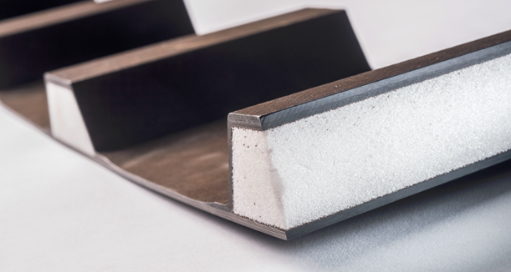

Caption:
ROHACELL® HERO also brings about benefits in manufacturing compared to conventional honeycomb structures. The fine-pore material allows complex components to be produced much more easily and more accurately. (Photo: Evonik Industries AG)

Company information
Evonik, the creative industrial group from Germany, is one of the world leaders
in specialty chemicals. Profitable growth and a sustained increase in the value of the company form the heart of Evonik’s corporate strategy. Its activities focus on the key megatrends health, nutrition, resource efficiency and globalization. Evonik benefits specifically from its innovative prowess and integrated technology platforms.

Evonik is active in over 100 countries around the world. In fiscal 2013 more than 33,500 employees generated sales of around €12.7 billion and an operating profit (adjusted EBITDA) of about €2.0 billion.

Disclaimer
In so far as forecasts or expectations are expressed in this press release or where our statements concern the future, these forecasts, expectations or statements may involve known or unknown risks and uncertainties. Actual results or developments may vary, depending on changes in the operating environment. Neither Evonik Industries AG nor its group companies assume an obligation to update the forecasts, expectations or statements contained in this release.

