February 13, 2015
Business Press Contact
Dr. Edda Schulze
Corporate Press
Phone +49 201 177-2555
Fax +49 201 177-3030
edda.schulze@evonik.com
Trade Press Contact
Dr. Karin Aßmann
Innovation Networks & Communications
Phone +49 6181 59-12230
Fax +49 6181 59-712230
karin.assmann@evonik.com

Evonik Industries AG
Rellinghauser Straße 1-11
45128 Essen
Germany
Phone +49 201 177-01
Telefax +49 201 177-3475
www.evonik.de

Supervisory Board
Dr. Werner Müller, Chairman
Executive Board
Dr. Klaus Engel, Chairman
Christian Kullmann
Thomas Wessel
Patrik Wohlhauser
Ute Wolf

Registered office Essen
Registered court
Essen local court
Commercial registry B 19474
VAT ID no. DE 811160003

Evonik optimizes the production of plasticizer alcohols

- Innovative catalyst significantly improves process
- Market for plasticizer alcohols has a volume of
5 million metric tons per year

In the future, Evonik Industries will be able to produce the plasticizer alcohol 2-propyl heptanol (2-PH) much more efficiently at the Marl site. This is made possible by the development of the new ligand OxoPhos 64i; ligands are important components of catalysts and essential for many large-scale processes. The new ligand makes the process more efficient and enables longer plant operation and less maintenance. With this innovation Evonik strengthens its technology position in the attractive growth market for plasticizer alcohols.

Plasticizer alcohols have a volume of 5 million metric tons per year and represent an interesting, continuously growing market for Evonik. Besides 2-PH, the company also produces the plasticizer alcohol isononanol (INA) on a world-scale level. With a capacity for both alcohols of more than 400,000 metric tons annually, Evonik is the largest manufacturer of C9/C10 plasticizer alcohols in Europe.

The plasticizer alcohol 2-PH is produced using the so-called oxo reaction. An alkene is transformed using a mixture of carbon monoxide and hydrogen as well as a catalyst system, which is made of a metal and a ligand. Because this key step is one of the most cost intensive process steps, Evonik has developed OxoPhos 64i using cutting-edge methods such as computational chemistry. The improved process started at the end of 2014.

The process improvement is sustainably impacting the whole C4 integrated production network of Evonik at the Marl site. With this production network Evonik converts C4 crack generated in crude oil processing to high-quality precursors and products such as butadiene, MTBE or plasticizer alcohols.

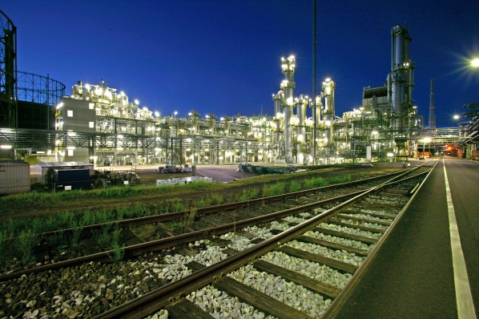

Capture:
Plant for the production of the plasticizer alcohol 2-propylheptanol in Marl (Photo: Evonik Industries AG)

Company information
Evonik, the creative industrial group from Germany, is one of the world leaders
in specialty chemicals. Profitable growth and a sustained increase in the value of the company form the heart of Evonik’s corporate strategy. Its activities focus on the key megatrends health, nutrition, resource efficiency and globalization. Evonik benefits specifically from its innovative prowess and integrated technology platforms.

Evonik is active in over 100 countries around the world. In fiscal 2013 more than 33,500 employees generated sales of around €12.7 billion and an operating profit (adjusted EBITDA) of about €2.0 billion.

Disclaimer
In so far as forecasts or expectations are expressed in this press release or where our statements concern the future, these forecasts, expectations or statements may involve known or unknown risks and uncertainties. Actual results or developments may vary, depending on changes in the operating environment. Neither Evonik Industries AG nor its group companies assume an obligation to update the forecasts, expectations or statements contained in this release.

