February 4, 2015
Contact person economic press
Dr. Edda Schulze
Corporate Press
Phone +49 201 177-2555
Fax +49 201 177-3030
edda.schulze@evonik.com
Technical media contact
Dr. Karin Aßmann
Innovation Networks & Communication
Phone +49 6181 59-12230
Fax +49 6181 59-712230
karin.assmann@evonik.com

Evonik Industries AG
Rellinghauser Straße 1-11
45128 Essen
Germany
Phone +49 201 177-01
Telefax +49 201 177-3475
www.evonik.de

Supervisory Board
Dr. Werner Müller, Chairman
Executive Board
Dr. Klaus Engel, Chairman
Christian Kullmann
Thomas Wessel
Patrik Wohlhauser
Ute Wolf

Registered office Essen
Registered court
Essen local court
Commercial registry B 19474
VAT ID no. DE 811160003

Industrial chromatography and reverse osmosis optimize amino acid fermentation process

- Evonik improves environmental performance of amino acid production
- Higher efficiency in fermentation broth downstream processing
- Evonik Fermas in Slovakia successfully operates improved process

Using creativity and unconventional ideas, researchers and engineers at Evonik have achieved a significant breakthrough in the biotechnological production of amino acids based on fermentation. They integrated the separating methods of chromatography and reverse osmosis and an online analytical method based on spectroscopy—all of which tend to be used in other industry sectors—in a biotechnological process. This created an outcome experts had previously considered nearly impossible. The researchers' objective was to achieve optimal separation of the desired amino acid from a fermentation broth.

"Innovation must be preceded by a good idea and the ability to think outside the box. Our scientists need self-initiative and persuasiveness to turn an idea into an innovation. The innovation that managed to increase the amino acid yield is so successful that it won our internal Innovation Award," said Dr. Ulrich Küsthardt, Chief Innovation Officer of Evonik.

In the fermentative production of amino acids, Evonik exploits the ability of microorganisms to produce complex molecules such as certain amino acids in a vessel at moderate conditions. The downstream purification and treatment process is also a key factor in product quality and yield. The special challenge of the downstream fermentation process is that the composition of the fermentation broth fluctuates considerably. This overstrains many of the proven separating technologies and they are less efficient than they should be.

The skillful combination of the three methods brought the desired success: a continuous chromatography process that separates the amino acids from the fermentation broth with high selectivity, thereby increasing product yields; a reverse osmosis process that removes water from the broth and, combined with the chromatography process, significantly increases the efficiency of the entire process; and a process monitoring system based on near-infrared spectroscopy allows to operate the process in the optimal range.

Evonik Fermas in Slovakia has been using this expanded downstream process successfully for the past two years. It has led to significant improvements in product yields, productivity, production costs, and environmental performance. The new findings have also been transferred to other fermentation processes. But the process experts aren't stopping here: Based on their findings they are currently studying how to reduce the use of thermal energy in the production of amino acids even further.

Evonik is the only company worldwide to produce and market the four most important essential amino acids for modern animal nutrition, including MetAMINO® (DL-methionine), Biolys®
(L-lysine), ThreAMINO® (L-threonine) and TrypAMINO®
(L-tryptophan). Pure amino acids are produced with biotechnology methods. Evonik provides innovative services and products in over 100 countries, making a valuable contribution to the profitability of its customers, while contributing to healthy, environmentally friendly and sustainable animal nutrition.

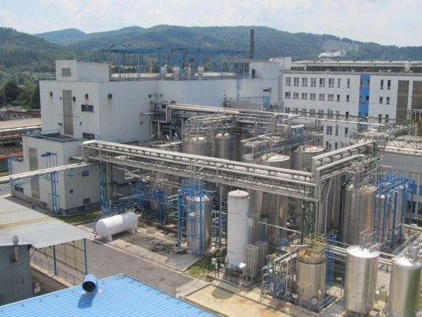

Photo: Evonik Fermas in Slovakia has been using the expanded downstream process successfully for the past two years (photo: Evonik Industries AG)

Company information
Evonik, the creative industrial group from Germany, is one of the world leaders
in specialty chemicals. Profitable growth and a sustained increase in the value of the company form the heart of Evonik’s corporate strategy. Its activities focus on the key megatrends health, nutrition, resource efficiency and globalization. Evonik benefits specifically from its innovative prowess and integrated technology platforms.

Evonik is active in over 100 countries around the world. In fiscal 2013 more than 33,500 employees generated sales of around €12.7 billion and an operating profit (adjusted EBITDA) of about €2.0 billion.

Disclaimer
In so far as forecasts or expectations are expressed in this press release or where our statements concern the future, these forecasts, expectations or statements may involve known or unknown risks and uncertainties. Actual results or developments may vary, depending on changes in the operating environment. Neither Evonik Industries AG nor its group companies assume an obligation to update the forecasts, expectations or statements contained in this release.

