October 19, 2016

Contact person specialized press
Doris Hirsch
Communication Molding Compounds
Performance Materials
Phone +49 6151 18-4079
Fax +496151 18-844079
doris.hirsch@evonik.com
Evonik Performance
Materials GmbH
Rellinghauser Straße 1-11
45128 Essen
Germany
Phone +49 201 177-01
Fax +49 201 177-3475
www.evonik.com

Managing Directors
Johann-Caspar Gammelin, Chairman
Dr. Michael Pack,
Magdalena Wagner,
Rainer Wobbe

Registered Office Essen
Register Court
City Local Court Essen
Commercial Registry B 25779
K 2016, Hall 6 Booth-No. B28

CYROLITE® - Multipolymer Compounds for Medical Devices

- CYROLITE® multipolymer compounds are the most highly developed PMMA-based polymers for medical devices
- The material is resistant to alcohol and lipids and is also impact-resistant, transparent, and translucent
- CYROLITE® is based on more than 40 years’ experience in medical and diagnostic applications

Polymers have long been indispensable in hospitals, laboratories, and medical surgeries, where they are found in items such as disposable items, medical filters, and device housings. But in this sensitive area, the materials that are used must fulfill extremely high quality and safety requirements. Evonik's Performance Materials Segment has more than 40 years’ experience in medical technology and markets CYROLITE® especially for medical and diagnostic applications.

The multipolymer compounds are the world's most advanced PMMA-based polymers for medical devices. They can be sterilized with gamma rays, e-beam, and EtO gas, are resistant to alcohol and lipids and have good impact resistance, transparency, and translucency properties. All CYROLITE® grades meet the requirements of USP classes 6 and 26, Tripartite, ISO 10993-1 and FDA and are free from Bisphenol A (BPA), Bisphenol S (BPS) and Diethyl hexylphthalat (DEHP).

Special variants of the material for different applications

Typical applications that are produced from CYROLITE® multipolymer compounds include disposable medical items, such as IV and catheter accessories, blood/plasma separators, chest drainage sets, medical filter and device housings. Evonik has also developed different variants of CYROLITE® multipolymer compounds for special applications.

For example, the special molding compounds CYROLITE® Protect and CYROLITE® Protect 2 are microbe resistant PMMA-based compounds. They remain permanently microbe resistant even after repeated cleaning and thus help to prevent infections caused by hospital microorganisms that are increasingly becoming a problem.

CYROLITE® MD PMMA is an adapted variant which is suitable for diagnostic applications, such as cuvettes, test sets, rotors, and crystallography trays, that meets all the relevant requirements. The materials that are used in this area must have good optical properties. CYROLITE® MD PMMA offers exceptional ultra-violet light transmittance (UVT) and optical clarity in combination with maximum flow properties and high dimensional stability.

Inhalers need an anti-static mouthpiece so that the active ingredient can be inhaled. Vu-Stat™ Y-20 is a transparent, electro-static dissipative PMMA-based multipolymer used mainly for molding medical applications. In addition to inhalers, it is also used for needle hubs for brachytherapy and electronic components with dust-resistant surfaces.

Good processing properties

But CYROLITE® multipolymer compounds not only have properties that make them ideal for use in medical applications: because of their good flow properties, they can also be processed into delicate shapes as well as large components. Filling multiple cavities in injection molding dies is also not a problem, which allows disposable items to be manufactured very economically.

More than 40 years’ experience

Evonik has more than 40 years’ experience in medical and diagnostic applications and, with its high level of expertise in polymer development and processing, offers a large range of medical quality polymers. The company also has experienced customer service and sales teams who provide outstanding technical service.

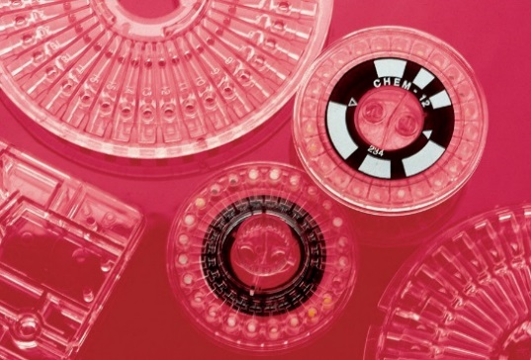

Caption:
CYROLITE® Multipolymers for medical and diagnostic applications.

Company information
Evonik, the creative industrial group from Germany, is one of the world leaders in specialty chemicals, operating in the Nutrition & Care, Resource Efficiency and Performance Materials segments. The company benefits from its innovative prowess and integrated technology platforms. In 2015 more than 33,500 employees generated sales of around €13.5 billion and an operating profit (adjusted EBITDA) of about €2.47 billion.

About Performance Materials
The Performance Materials Segment is managed by Evonik Performance Materials GmbH. The segment focuses its global activities on developing and manufacturing polymer materials and intermediates, especially for use in agriculture and in the rubber and plastics industry. In 2015, the segment’s roughly 4,400 employees generated sales about €3.4 billion.

Disclaimer
In so far as forecasts or expectations are expressed in this press release or where our statements concern the future, these forecasts, expectations or statements may involve known or unknown risks and uncertainties. Actual results or developments may vary, depending on changes in the operating environment. Neither Evonik Industries AG nor its group companies assume an obligation to update the forecasts, expectations or statements contained in this release.

