March 29, 2017

Press Contact
Dr. Jürgen Krauter
Head of Communications
Nutrition & Care
Phone +49 6181 59-6847
Fax +49 6181 59-76847
juergen.krauter@evonik.com
Specialized Press Contact
Lisa Dierks
Head of Communications
Baby Care
Phone +49 201 173-3170
Fax +49 201 173-713170
lisa.dierks@evonik.com
Evonik Nutrition & Care GmbH
Rellinghauser Straße 1-11
45128 Essen
Germany
Telefone +49 201 177-01
Fax +49 201 177-3475

www.evonik.com

Supervisory Board
Dr. Ralph Sven Kaufmann, Chairman

Management Board
Dr. Reiner Beste, Chairman
Dr. Hans Josef Ritzert
Michael Gattermann
Markus Schäfer
Registered office Essen
Registered court
Essen local court
Commercial registry B 25784
HR no. FN 431387 v

Evonik presents new generation of superabsorbents

Essen, Germany. With FAVOR®max, Evonik has developed the next generation of superabsorbents with unique properties which make baby diapers and incontinence products even more absorbent and reliable. With the new superabsorbents from Evonik, hygiene product manufacturers can further improve the performance of their products to meet even better the requirements of diverse customer groups. Evonik will present FAVOR®max at the INDEX17 trade fair which takes place in Geneva, Switzerland, from April 4 to 7.

Just a few grams of the new FAVOR®max high-performance superabsorbent ensure fast absorption of large amounts of fluids and lasting dryness. This is made possible through a finely balanced combination of the superabsorbent’s key performance parameters, which are adapted to the specific design of the absorbent core. As a result of the optimal interaction with other components of the hygiene product, its performance is improved even more.

FAVOR®max 1000 has been designed for use in ultra-thin diapers. Thanks to the unique profile of the perfectly aligned parameters, the new superabsorbent has improved the fluid dynamics within the absorbent core and has reduced the risk of leakage. This is achieved through greater fluid retention while retaining constant absorption under pressure, combined with permeability and higher absorption speed.

For use in absorbent cores with a high percentage of fluff pulp, the superabsorbents of the FAVOR®max 2000 product family feature high absorption capacity even when under pressure, high retention and absorption speed. When used in incontinence products, the material ensures that large quantities of fluids are absorbed quickly and securely.

To complement these products, the specialists in Evonik’s Baby Care Business Line offer additional solutions. These include, for example, odor control, color stability of the superabsorbent material even under challenging climatic conditions, and optimal processability for the customer.

Optimal hygiene products can only be developed once the interaction of superabsorbents, absorbent cores, and other article components is understood. Evonik experts analyze the effectiveness of the superabsorbents using proprietary as well as key industry test methods. The focus is on the performance of the material starting with the pure superabsorbent in the development phase and going right up to the finished product.
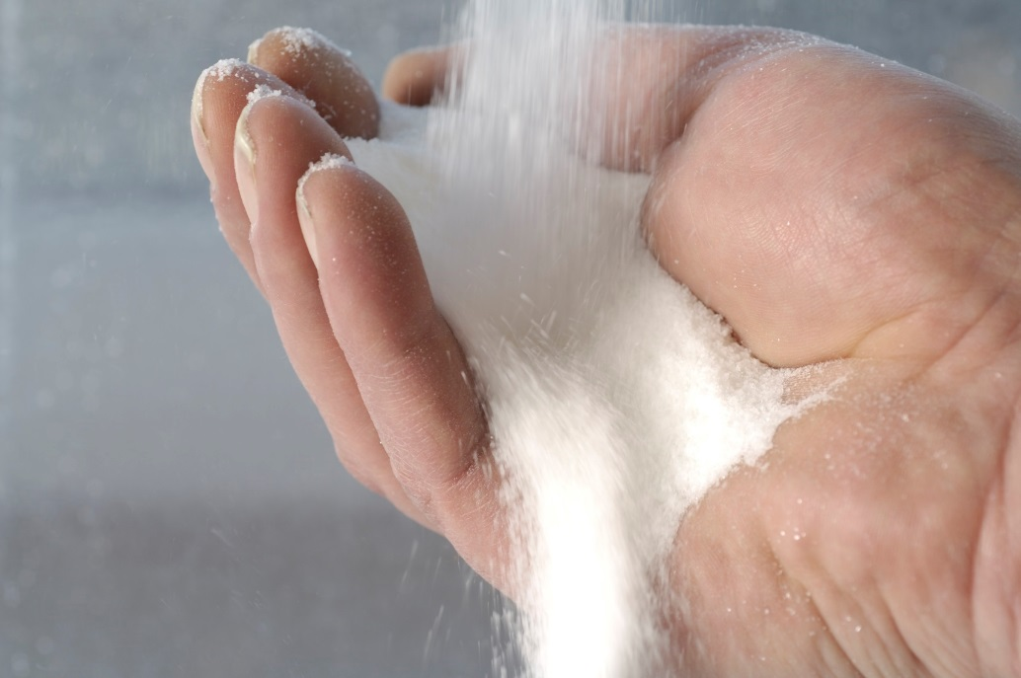

Caption:
Just a few grams of the new FAVOR®max high-performance superabsorbent ensure fast absorption of large amounts of fluids and lasting dryness.

Company information
Evonik, the creative industrial group from Germany, is one of the world leaders in specialty chemicals. Profitable growth and a sustained increase in the value of the company form the heart of Evonik’s corporate strategy. Evonik benefits specifically from its innovative prowess and integrated technology platforms. Evonik is active in over 100 countries around the world with more than 35,000 employees. In fiscal 2016 the enterprise generated sales of around €12.7 billion and an operating profit (adjusted EBITDA) of about €2.165 billion.

About Nutrition & Care
The Nutrition & Care segment is led by Evonik Nutrition & Care GmbH and contributes to fulfilling basic human needs. That includes applications for everyday consumer goods as well as animal nutrition and health care. This segment employed about 7,500 employees, and generated sales of around
€4.3 billion in 2016.

Disclaimer
In so far as forecasts or expectations are expressed in this press release or where our statements concern the future, these forecasts, expectations or statements may involve known or unknown risks and uncertainties. Actual results or developments may vary, depending on changes in the operating environment. Neither Evonik Industries AG nor its group companies assume an obligation to update the forecasts, expectations or statements contained in this release.

