September 17, 2014
Contact person economic press
Dr. Edda Schulze
Corporate Press
Phone +49 201 177-2555
Fax +49 201 177-3030
edda.schulze@evonik.com
Contact person specialized press
Dr. Jürgen Krauter
Communications Health & Nutrition
Phone +49 6181 59-6847
Fax +49 6181 59-76847
juergen.krauter@evonik.com
Evonik Industries AG
Rellinghauser Straße 1-11
45128 Essen
Germany
Phone +49 201 177-01
Telefax +49 201 177-3475
www.evonik.com

Supervisory Board
Dr. Werner Müller, Chairman
Executive Board
Dr. Klaus Engel, Chairman
Christian Kullmann
Thomas Wessel
Patrik Wohlhauser
Ute Wolf

Registered office Essen
Registered court
Essen local court
Commercial registry B 19474
VAT ID no. DE 811160003

At the right time, at the right place: Evonik’s biopolymers increase the effectiveness of drugs

- Next-generation biopolymers will enable easier and less invasive therapeutic options
- Future use of nanoparticles will allow for better drug release control
- Within the PeTrA¹ project, Evonik works with partners to find an oral delivery solution for biopharmaceuticals

Medications should work. They can only do so if the active reaches its targeted location in the body and remains in place long enough and at a high enough concentration. This is where Evonik’s expertise can help: Biodegradable polylactides (polylactic acids) and their copolymers, which Evonik markets under the brand names RESOMER® and RESOMER® Select, are especially suited to create sustained release formulations for modern drugs that are injected.

Most medications are taken orally, e.g., as tablets or capsules. However, many modern protein or nucleic acid-based biotherapeutics, such as those used to combat cancer, diabetes or multiple sclerosis, must be administered by injection – under the skin (subcutaneously), into the muscles (intramuscular) or directly into the vein (intravenously).

Drug efficacy is often influenced by the formulation. So-called sustained release formulations provide controlled release of drugs over a longer period. "We formulate modern biotherapeutics with our RESOMER® biopolymers and so enable gentle and effective treatment options," said Dr. Jean-Luc Herbeaux, Head of Evonik’s Health Care Business Line. The finished product is usually formulated as microparticles or as rod implants to be injected subcutaneously or intramuscularly - depending on the desired effect. The active ingredient is continuously released over a defined period as the body gradually degradates the polymer matrix.

"With the help of novel biopolymers, we hope it will be possible in the future to bring biopharmaceuticals into the bloodstream through the gastro-intestinal tract and through respiratory pathways rather than through injections," added Herbeaux. As part of PeTrA, a project co-funded by the German Federal Ministry of Education and Research, Evonik has worked with partners to develop novel biocompatible and biodegradable lactic and glycolic acid-based copolymers (PLGAs) and test them in cell models.

Improved tolerability through parenteral sustained release formulations—today

In cases where it is necessary to inject biopharmaceuticals, biodegradable polylactic acids from Evonik have long proven their benefits. The advantages can be seen, for example, with patients who are suffering from a certain type of prostate cancer and treated with a so-called LHRH antagonist. These drugs aim to stem the progress of hormone-dependent cancer by suppressing testosterone production. Since a constant drug level is required, the LHRH antagonist would actually need to be injected several times a day. Thanks to a polymer-based sustained release formulation that is injected under the skin in the shape of a small rod, injection is only necessary every six months thereby increase comfort and compliance and reducing cost of treatment.

Dr. Boris Obermeier, who is responsible for developing biopolymers at Evonik, sees the use of nanoparticles as a step toward even more targeted drug delivery systems. "With customized polymers and suitable formulations, we can protect drugs from the attacks of the immune system, allow them to circulate longer in the blood stream and precisely accumulate in a particular tissue," explained Obermeier at Evonik’s Evonik Meets Science forum in Fulda, Germany.

Applications in the medical technology of today and tomorrow

Biodegradable polymers have also found a place in medical device applications. A wide variety of medical devices can be produced from polylactic acids - from a simple screw or plate to stabilize a broken bone, to absorbable stents. The advantage of these applications: the material is programmed to be metabolized by the body within months to years and a removal by a second surgery is not necessary.

As Obermeier demonstrated in Fulda, there are interesting application opportunities consisting of loading medical devices with an active pharmaceutical ingredient for local delivery. In the spring, Evonik opened a new Medical Devices Project House to develop new polymer-based system solutions for medical engineering applications.

Future opportunities for biodegradable polymers lie in the synthetic production of biological tissue to replace or regenerate diseased tissue in patients. Biological tissues need a stabilizing matrix that the cells can grow on. A matrix made of biodegradable polymers present the advantage to be absorbed by the body later on.

“All of these applications need well-tolerated materials whose properties can be adjusted to suit specific requirements,” said Obermeier. This is the particular strength of the polylactic acids and their copolymers. Evonik is one of the leading product and service providers for the pharmaceutical and medical device industries in this field, with its own development and production capacities for functional polymers in Darmstadt (Germany) and Birmingham (Alabama, USA).

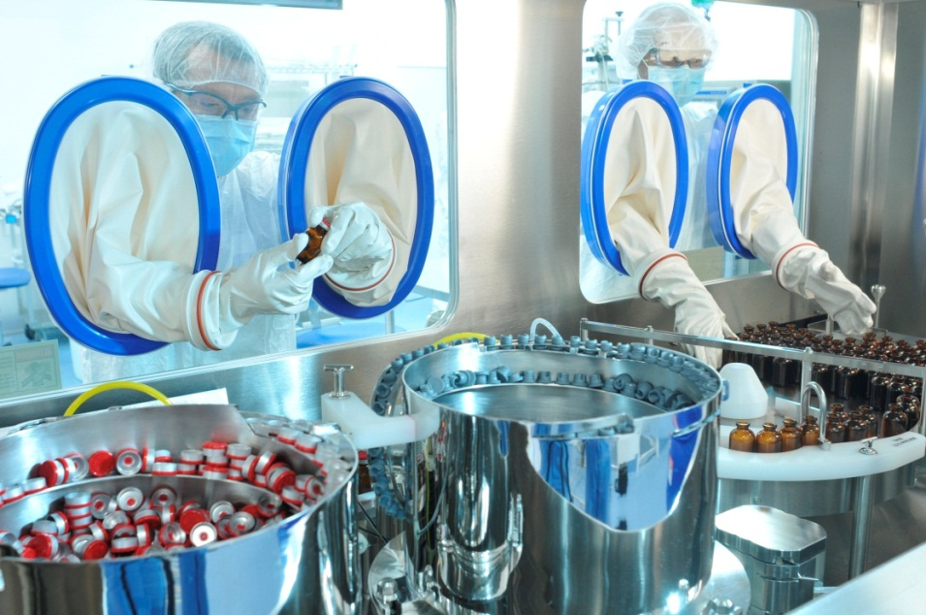

Capture: Production of parenteral medications requires the highest hygienic standards. Shown here is the site in Birmingham (Alabama, USA)

Company information
Evonik, the creative industrial group from Germany, is one of the world leaders
in specialty chemicals. Profitable growth and a sustained increase in the value of the company form the heart of Evonik’s corporate strategy. Its activities focus on the key megatrends health, nutrition, resource efficiency and globalization. Evonik benefits specifically from its innovative prowess and integrated technology platforms.

Evonik is active in over 100 countries around the world. In fiscal 2013 more than 33,500 employees generated sales of around €12.7 billion and an operating profit (adjusted EBITDA) of about €2.0 billion.

Disclaimer
In so far as forecasts or expectations are expressed in this press release or where our statements concern the future, these forecasts, expectations or statements may involve known or unknown risks and uncertainties. Actual results or developments may vary, depending on changes in the operating environment. Neither Evonik Industries AG nor its group companies assume an obligation to update the forecasts, expectations or statements contained in this release.

PeTrA stands for “Platform for efficient epithelial transport of pharmaceutical applications with innovative particular carrier systems” (Evonik Funding Ref. No.: 13N11454) and is part of the BMBF grant project “Efficient drug transport in biological systems - BioMatVital: Biotransporters”. A consortium consisting of Evonik Industries AG, Merck KGaA, EMC microcollections GmbH, the Helmholtz Center for Infection Research (HZI), and the Fraunhofer Institute for Interfacial Engineering and Biotechnology (IGB) are responsible for PeTrA. The University of Nijmegen (Netherlands), Friedrich Schiller University in Jena, Saarland University, Bonn University Hospital, Charité Hospital Berlin, Kiel University, and Würzburg University (all in Germany) are also involved in the project.

