June 23, 2014
Contact person specialized press
Dr. Karin Aßmann
Innovation Networks & Communication
Phone +49 6181 59-12230
Fax +49 6181 59-712230
karin.assmann@evonik.com

Evonik Industries AG
Rellinghauser Straße 1-11
45128 Essen
Germany
Phone +49 201 177-01
Telefax +49 201 177-3475
www.evonik.de

Supervisory Board
Dr. Werner Müller, Chairman
Executive Board
Dr. Klaus Engel, Chairman
Thomas Wessel
Patrik Wohlhauser
Ute Wolf
Registered office Essen
Registered court
Essen local court
Commercial registry B 19474
VAT ID no. DE 811160003

Evonik strengthens involvement of external partners in research and development

- ECRP is a new approach to building networks with outstanding scientists
- Very successful start in 2013: three partnership agreements currently under negotiation

In mid-June, Evonik Industries invited selected scientists from various universities faculties and research institutes to submit solutions to three pre-defined problems. Scientists have until the end of November to take part in this Evonik Call for Research Proposals (ECRP). With this new approach, Evonik hopes to gather creative ideas and proposals that, ideally, can result in a joint research project.

“In light of ever shorter innovation cycles and increasingly complex innovation topics, we are looking to strengthen the involvement of external partners in our own research and development work," said Dr. Peter Nagler, Chief Innovation Officer of Evonik.

The specialty chemicals company gained its first experience with this format in 2013. “For the most part, the feedback from the professors following the first ECRP was extremely positive. Almost all welcomed this new approach and expressed interest in taking part again," says Dr. Georg Oenbrink, head of the Innovation Networks & Communications department at Evonik. Three proposals on the topic of methionine synthesis without hydrogen cyanide as building block were so good that the Health & Nutrition Business Unit intends to form a partnership with the professors involved. The contracts are currently under negotiation.

The three current ECRPs focus on a new technology for masking the taste of pharmaceutical ingredients and dietary supplements (Health & Nutrition Business Unit); a donor-acceptor concept for the quantitative determination of fragments of oil additives that protect against wear, even under high pressure (Coatings & Additives Business Unit); and a technology that can be used to create thin, transparent layers with extremely good barrier properties from the liquid phase (Creavis, Evonik's strategic innovation unit). Interested scientists from universities and research institutes can request the call for proposals and rules of participation at ECRP@evonik.com.

About Evonik
Evonik, the creative industrial group from Germany, is one of the world leaders in specialty chemicals. Profitable growth and a sustained increase in the value of the company form the heart of Evonik’s corporate strategy. Its activities focus on the key megatrends health, nutrition, resource efficiency and globalization. Evonik benefits specifically from its innovative prowess and integrated technology platforms.

Evonik is active in over 100 countries around the world. In fiscal 2013 more than 33,500 employees generated sales of around €12.7 billion and an operating profit (adjusted EBITDA) of about €2.0 billion.

Disclaimer
In so far as forecasts or expectations are expressed in this press release or where our statements concern the future, these forecasts, expectations or statements may involve known or unknown risks and uncertainties. Actual results or developments may vary, depending on changes in the operating environment. Neither Evonik Industries AG nor its group companies assume an obligation to update the forecasts, expectations or statements contained in this release.

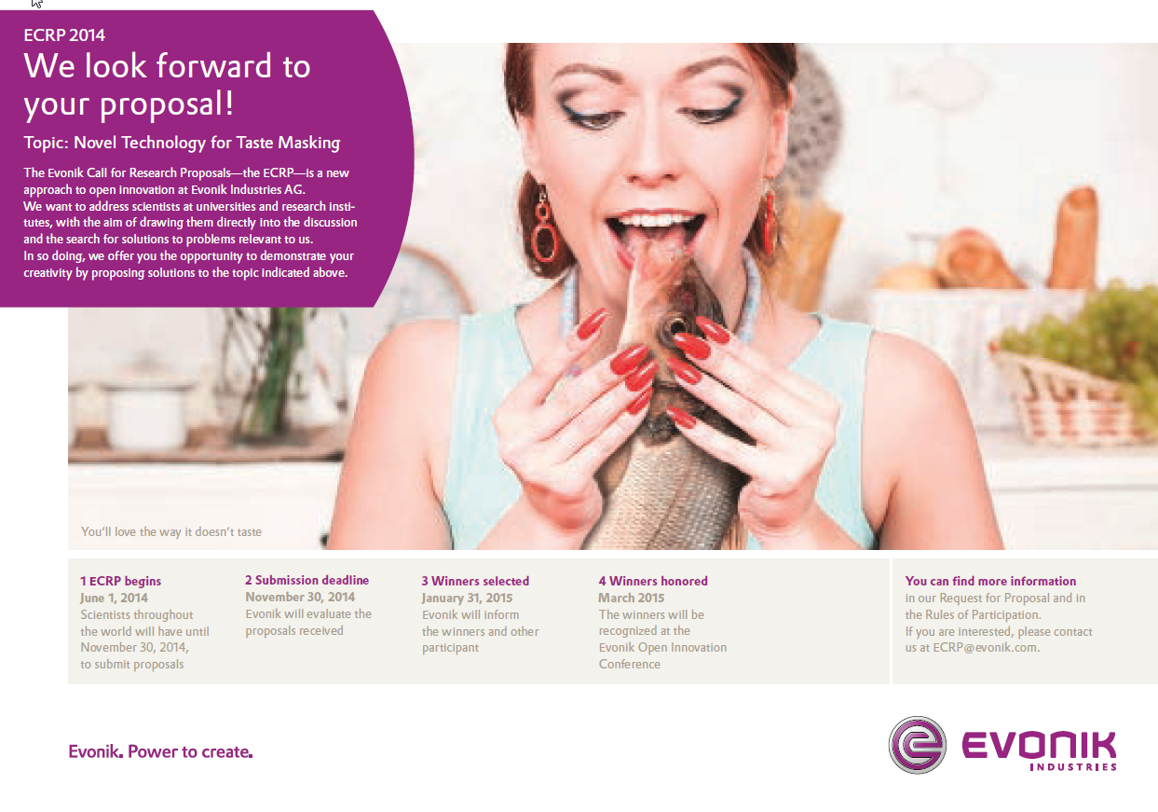
Capture:
One of 3 topics of this year´s Evonik Call for Research Proposals: a new technology for masking the taste of pharmaceutical ingredients and dietary supplements (Photo: Evonik Industries AG)

