September 12, 2014
Contact person specialized press
Dr. Jürgen Krauter
Health & Nutrition Communication
Phone: +49 6181 59-6847
Fax: +49 6181 59-76847
juergen.krauter@evonik.com
Evonik Industries AG
Rellinghauser Straße 1-11
45128 Essen
Germany
Phone +49 201 177-01
Telefax +49 201 177-3475
www.evonik.de

Supervisory Board
Dr. Werner Müller, Chairman
Executive Board
Dr. Klaus Engel, Chairman
Christian Kullmann
Thomas Wessel
Patrik Wohlhauser
Ute Wolf

Registered office Essen
Registered court
Essen local court
Commercial registry B 19474
VAT ID no. DE 811160003

Evonik starts construction of the first production plant for methionine dipeptide

Evonik Industries held a groundbreaking ceremony to celebrate the on-schedule start of construction on the first plant for the production of AQUAVI® Met-Met in Antwerp (Belgium). The product, a dipeptide made up of two methionine molecules, is a feed additive specially developed for shrimp and other crustaceans in aquacultures. The investment volume is in the lower double-digit-million-euro range.

Commercial quantities of the product will be available when the new plant commences operation in the second half of 2015. Customers can now request samples from Evonik to carry out joint feed studies. Feed studies on quantities from pilot plants are already underway worldwide.

“Adding a highly effective methionine source to the feed is just as profitable for shrimp and crustaceans as for fish. We now can offer our customers also for this species a tailor-made solution,” said Dr. Emmanuel Auer, head of the Animal Nutrition Business Line at Evonik in Antwerp.

AQUAVI® Met-Met significantly reduces the consumption of fish meal in shrimp aquaculture. It therefore lowers feed costs, reduces the strain on fishing grounds worldwide, and helps water purity by reducing the amount of waste produced by the animals and nitrogen output into the environment through an optimal supply of methionine. With optimal nutrition, the shrimp stay healthier and the environment is less polluted.

The Met-Met dipeptide is far less water soluble than other sources of methionine and, for this reason, will not wash out of the feed as quickly. Consequently, the shrimp, which feed slowly on the sea floor, are able to take in sufficient methionine. Their enzymes are also able to break AQUAVI® Met-Met back down into two individual methionine molecules. This way, the free amino acids can be efficiently used in precise synchronization with protein synthesis and growth.

“AQUAVI® Met-Met is not only an innovative source of methionine for shrimp but also the first dipeptide in the world to be produced on commercial industrial scale and be economically viable for use in animal nutrition,” said Dr. Christoph Kobler, the product manager for AQUAVI® Met-Met.

Aquacultures are a global growth market. By as early as 2015, 50 percent of edible meat from fish, crustaceans and shellfish is expected to come from aquacultures. With MetAMINO® and DL-Methionine for AquacultureTM, Evonik is already global market leader in feed amino acids for fish feed, especially in the salmonid feed segment (salmon, trout). AQUAVI® Met-Met will initially be offered for use with shrimp and crustaceans. Use with other species will follow.

Evonik is the only company in the world that produces and markets the four most important amino acids that are required in advanced animal feed: Biolys® (L-lysine source), MetAMINO® (DL-methionine), Mepron® (DL-methionine for ruminants), DL-Methionine for AquacultureTM, ThreAMINO® (L-threonine), and TrypAMINO® (L-tryptophan). As a solution provider, the Group also supports its customers with comprehensive professional advice, tailored services, and a worldwide sales organization for all amino acid products.

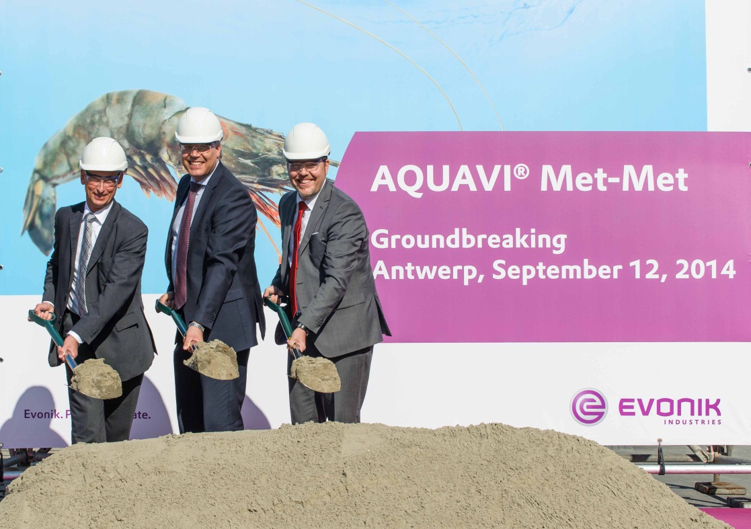
Caption:
From left:
Frank Daman, General Manager Evonik Degussa Antwerpen NV
Dr. Emmanuel Auer, head of Animal Nutrition business line
Dr. Christoph Kobler, head of product management aquaculture

Company information
Evonik, the creative industrial group from Germany, is one of the world leaders
in specialty chemicals. Profitable growth and a sustained increase in the value of the company form the heart of Evonik’s corporate strategy. Its activities focus on the key megatrends health, nutrition, resource efficiency and globalization. Evonik benefits specifically from its innovative prowess and integrated technology platforms.

Evonik is active in over 100 countries around the world. In fiscal 2013 more than 33,500 employees generated sales of around €12.7 billion and an operating profit (adjusted EBITDA) of about €2.0 billion.

Disclaimer
In so far as forecasts or expectations are expressed in this press release or where our statements concern the future, these forecasts, expectations or statements may involve known or unknown risks and uncertainties. Actual results or developments may vary, depending on changes in the operating environment. Neither Evonik Industries AG nor its group companies assume an obligation to update the forecasts, expectations or statements contained in this release.

