November 17, 2016

Specialized press contact
Dr. Viviana Steiner
Marketing Manager Road Marking
Phone + 49 6181 59-3296
Fax +49 6151 18-843750
viviana.steiner@evonik.com

Regional press contact
Janna Schneidewindt
Head of Regional Communication
South East Asia, Australia & NZ
Phone +65 6809 6820
Fax + 65 6809 6620
janna.schneidewindt@evonik.com

Evonik Resource Efficiency GmbH
Rellinghauser Straße 1-11
45128 Essen
Phone +49 201 177-01
Fax +49 201 177-3475
www.evonik.com

Supervisory Board
Dr. Ralph Sven Kaufmann, Chairman

Executive Board
Dr. Claus Rettig, Chairman
Dr. Johannes Ohmer,
Simone Hildmann,
Alexandra Schwarz

Registered Office: Essen
Register Court: Essen Local Court
Commercial Registry B 25783
VAT ID no. DE 815528487
Evonik presents its first Evonik Road Safety Award in Thailand

Evonik to award its first global ‘Evonik Road Safety Award’ to Department of Rural Roads, Thailand

Winning project has proven the effectiveness of colored road markings on improving Thailand’s rural school zones

€10,000 prize will be donated to Queen Sirikit National Institute of Child Health

Bangkok. Evonik Industries AG, one of the world’s leading specialty chemicals companies and the inventor of methylmethacrylate (MMA) cold plastic road markings, hosted an award ceremony at the Residence of the German Ambassador today to present the “Evonik Road Safety Award” to the Department of Rural Roads, Thailand (DRR), as an acknowledgment and reward for their contributions to road safety in Thailand, especially in rural areas.

Granted this year for the first time, the “Evonik Road Safety Award” is designed to support sustainable road safety initiatives and projects worldwide, as part of the company’s corporate and social responsibility. Evonik advocates good social development in all its global sites and thus, supports charitable undertakings that raises the quality of life. With H.E. Rolf Schulze, German Ambassador, Dr. Florian Kirschner, Country Head of Evonik Thailand, and Jochen Henkels, Business Director of Evonik Road Marking, bestowing the award to DRR on their infrastructure project ‘Increase Children Safety – School Zones’, it represents Evonik’s recognition of their contribution on enhancing road safety in 3,000 school-zones of rural areas in Thailand.

According to the World Health Organization (WHO), Thailand ranks among the countries with the highest number of traffic fatalities per capita. Many of the roads in Thailand, especially in rural areas, are suffering from poor pedestrian safety conditions. Footpaths have not been built and pedestrians are forced to walk on dirt paths, which can easily cause fatal road accidents. Even in school-zones, children are risking their lives daily to reach schools, as reports show that pedestrian accidents mostly involve children under the age of 10, particularly during the school term.

To improve the children’s safety in school-zone areas, DRR began their road safety pilot project at Nonthaburi province in 2013. Besides implementing speed limitations, visual communication to create awareness was key in DRR’s considerations. Through the installation of edge lines, colored anti-skid rumble stripes and pedestrian crossings based on MMA cold plastic-based road markings, they have successfully raised awareness of traffic participants. Students, as well as pedestrians, are now better guided, vehicles speed have also been reduced significantly and public transportations run smoothly and safely.

Since its implementation in 2013, DRR has been monitoring the accident rates, anti-skid performance and the conditions of their road safety materials. Until now, they have accounted zero accidents thus far, and the MMA cold plastic-based road markings remain durable and functional even after 3 years, with no maintenance required. Surveyed students and parents strongly agree that the installation makes the way to and from school safer. With such a successful outcome of the project, this innovative, sustainable and environmentally-friendly solution has already been applied countrywide across more than 700 schools, and will be extended to 3,000 rural schools in the near future. With €10,000 cash prize associated with the award, DRR has asked Evonik to donate it to Queen Sirikit National Institute of Child Health as part of their project’s objective to enhance child and adolescent safety in the country.

“By presenting this award to DRR, we wish to promote sustainable improvements in roadworks even further, while spreading road safety awareness among the public,” Dr. Florian Kirschner, Country Head of Evonik Thailand commented. “Evonik as the creative industrial group, will continue to address the road safety issues with our innovative solutions and build trustful relationships with the local communities.”

The “Evonik Road Safety Award” will be bestowed every year. It assesses entries based on their contribution to road safety (60%) and sustainability (20%), as well as their innovative character (10%) and potential replicability (10%). Every applicant were screened by an independent jury of internationally recognized experts in the field of road safety, transport, and city design; among others is the International Road Federation (IRF) Geneva.

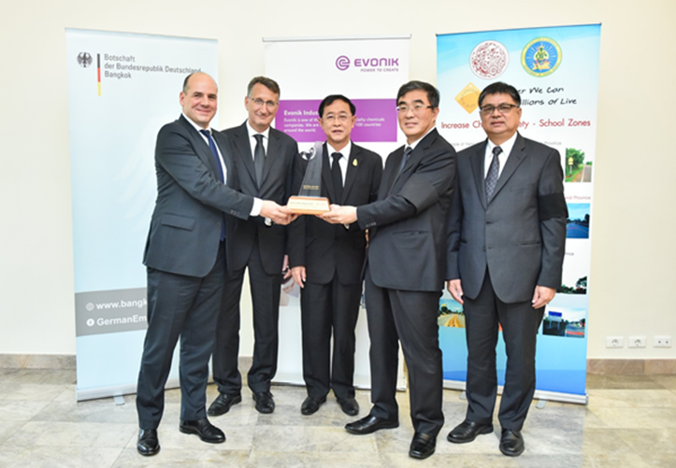

Caption
Evonik Road Safety Award Ceremony, November 16, 2016
(from left to right):

- Mr. Jochen Henkels, Business Director of Evonik Road Marking Business Line
- His Excellency Mr. Peter Prügel, Ambassador of the Federal Republic of Germany to Thailand
- His Excellency Mr. Arkhom Termpittayapaisith, Minister of Transport, Thailand
- Mr. Pisak Jitviriyavasin, Director General of Department of Rural Roads, Thailand
- Mr. Samai Chotisakul, Deputy Director General of Department of Rural Roads, Thailand

Company information
Evonik, the creative industrial group from Germany, is one of the world leaders in specialty chemicals, operating in the Nutrition & Care, Resource Efficiency and Performance Materials segments. The company benefits from its innovative prowess and integrated technology platforms. In 2015 more than 33,500 employees generated sales of around €13.5 billion and an operating profit (adjusted EBITDA) of about €2.47 billion.

Evonik in South East Asia, Australia & New Zealand (SEAANZ)
Headquartered in Singapore, Evonik is present in the SEAANZ region with production sites, sales offices, innovation and technical service centers located in Australia, Indonesia, Malaysia, New Zealand, Pakistan, Philippines, Singapore, Thailand and Vietnam. With more than 800 employees in the region, the company steadily grows its footprint in SEAANZ by expanding its regional operations in response to the growing demand. Evonik Industries has been establishing customer relationships and importing a broad range of products in the SEAANZ region since the 1920’s.

About Resource Efficiency
The Resource Efficiency segment is led by Evonik Resource Efficiency GmbH and supplies high performance materials for environmentally friendly as well as energy-efficient systems to the automotive, paints & coatings, adhesives, construction, and many other industries. This segment employed about 8,600 employees, and generated sales of around €4.3 billion in 2015.

Disclaimer
In so far as forecasts or expectations are expressed in this press release or where our statements concern the future, these forecasts, expectations or statements may involve known or unknown risks and uncertainties. Actual results or developments may vary, depending on changes in the operating environment. Neither Evonik Industries AG nor its group companies assume an obligation to update the forecasts, expectations or statements contained in this release.

